Chapter 14 Exterior Walls
CALIFORNIA BUILDING CODE — MATRIX ADOPTION TABLE
CHAPTER 14 — EXTERIOR WALLS
(Matrix Adoption Tables are nonregulatory, intended only as an aid to the code user.
See Chapter 1 for state agency authority and building applications.)
Adopting agency | BSC | BSC-  CG | SFM | HCD |  |  | DSA |  |  | OSHPD |  |  |  |  |  |  | BSCC | DPH | AGR | DWR | CEC | CA | SL | SLC
 |  |  |  | 1 | 2 | 1/AC | AC | SS | SS/CC | 1 | 1R | 2 | 3 | 4 | 5 | 6
Adopt entire chapter | X |  |  | X | X |  |  |  |  |  |  |  | X |  |  | X
Adopt entire chapter as  amended (amended  sections listed below) |  |  |  |  |  |  |  | X | X | X | X | X |  | X | X
Adopt only those  sections that are listed  below |  | X | X |  |  |  |  |  |  |  |  |  |  |  |  |  |  |  |  |  | X
Chapter / Section
1401 |  |  | X
1402 |  |  | X
1402.2.1 |  | X
1403 |  |  | X
1404 |  |  | X
1404.1.2 |  |  |  |  |  |  |  | X | X | X | X | X |  | X | X
1404.3.3 |  |  |  |  |  |  |  |  |  |  |  |  |  |  |  |  |  |  |  |  | X
1405 |  |  | X
1406 |  |  | X
1407 |  |  | X
1408 |  |  | X
1411 |  |  | X
1412 |  |  | X
1413 |  |  |  |  |  |  |  | X | X | X | X | X |  | X | X
The state agency does not adopt sections identified with the following symbol: †
The Office of the State Fire Marshal's adoption of this chapter or individual sections is applicable to structures regulated by other state agencies pursuant to Section 1.11.
User notes:
About this chapter: Chapter 14 addresses requirements for exterior walls of buildings. Minimum standards for wall covering materials, such as material performance and fire resistance, installation of wall coverings and the ability of the wall to provide weather protection are provided. This chapter also contains limitations on the areas and heights of combustible wall coverings based on fire separation distances, radiant heat exposure and surface burning characteristics.
ICC code development note: Code change proposals to sections preceded by the designation [BS] will be considered by the IBC—Structural Code Development Committee during the 2025 (Group B) Code Development Cycle.
Section 1401 General
1401.1 Scope
The provisions of this chapter shall establish the minimum requirements for exterior walls, exterior wall assemblies, exterior wall coverings, exterior wall openings, exterior windows and doors, exterior soffits and fascias, and architectural trim.
Section 1402 Performance Requirements
Diagram
UpCodes Diagrams (2)
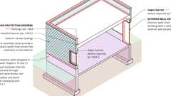
Exterior Envelope: Weather Protection
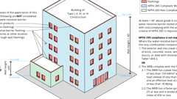
Combustible Water Resistive Barriers
1402.1 General
The provisions of this section shall apply to exterior walls, exterior wall coverings and components thereof.
1402.2 Weather Protection
Buildings shall be provided with a weather-resistant exterior wall assembly. The exterior wall assembly shall include flashing, as described in Section 1404.4. The exterior wall assembly shall be designed and constructed in such a manner as to prevent the accumulation of water within the exterior wall assembly by providing a water-resistive barrier behind the exterior veneer, as described in Section 1403.2, and a means for draining water that enters the assembly to the exterior. Protection against condensation in the exterior wall assembly shall be provided in accordance with Section 1404.3.
Exceptions:
- A weather-resistant exterior wall assembly shall not be required over concrete or masonry walls designed in accordance with Chapters 19 and 21, respectively.
- Compliance with the requirements for a means of drainage, and the requirements of Sections 1403.2 and 1404.4, shall not be required for an exterior wall assembly that has been demonstrated through testing to resist wind-driven rain, including joints, penetrations and intersections with dissimilar materials, in accordance with ASTM E331 under the following conditions:
The exterior wall design shall be considered to resist wind-driven rain where the results of testing, in accordance with ASTM E331, indicate that water did not penetrate control joints in the exterior wall, joints at the perimeter of openings or intersections of terminations with dissimilar materials.
  - Exterior wall test assemblies shall include not fewer than one opening, one control joint, one wall/eave interface and one wall sill. Tested openings and penetrations shall be representative of the intended end-use configuration.
  - Exterior wall test assemblies shall be not less than 4 feet by 8 feet (1219 mm by 2438 mm) in size.
  - Exterior wall test assemblies shall be tested at a minimum differential pressure of 6.24 pounds per square foot (0.297 kN/m²).
  - Exterior wall test assemblies shall be subjected to a minimum test exposure duration of 2 hours.
- Exterior insulation and finish systems (EIFS) complying with Section 1407.4.1.
Building products (10)
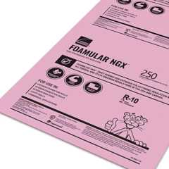
FOAMULAR® NGX® 250
Owens Corning


HOMESEALR®
Owens Corning

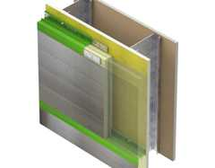
SMARTci® (on closed framing)
Advanced Architectural Products

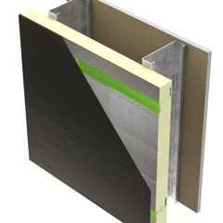
SMARTci® (on open framing)
Advanced Architectural Products

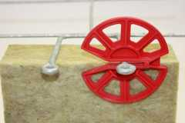
Thermafiber® RainBarrier® Clip
Owens Corning

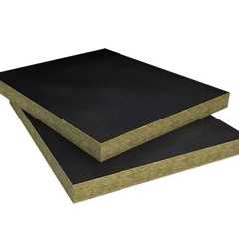
Thermafiber® RainBarrier® Dark™
Owens Corning

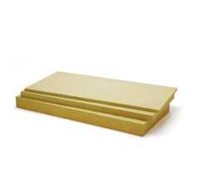
Thermafiber® RainBarrier® Semi-Rigid Insulation
Owens Corning

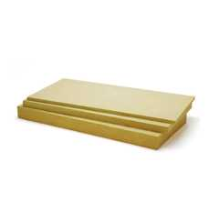
Thermafiber® RainBarrier® ci High Compressive (80)
Owens Corning

Thermafiber® RainBarrier® ci High Compressive Max (140)
Owens Corning

Thermafiber® RainBarrier® ci High Compressive Plus (110)
Owens Corning

1402.2.1
[BSC-CG] See California Green Building Standards Code, Chapter 5, Division 5.4 for additional weather protection requirements.
[BS] 1402.3 Wind Resistance
Exterior walls, exterior wall coverings, exterior soffits and fascias, and the associated openings, shall be designed and constructed to resist safely the superimposed loads required by Chapter 16.
Building products (6)
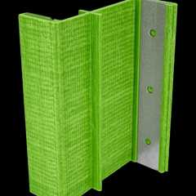
GreenGirt CMH Clips™
Advanced Architectural Products

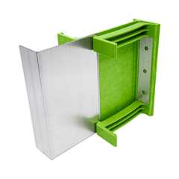
GreenGirt CMH Delta™ Adjustable
Advanced Architectural Products

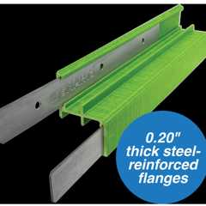
GreenGirt Max CMH™
Advanced Architectural Products

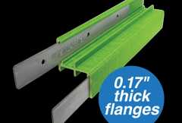
GreenGirt Optima CMH™
Advanced Architectural Products

SMARTci® (on open framing)
Advanced Architectural Products

Thermafiber® RainBarrier® Clip
Owens Corning

[BS] 1402.3.1 Attachments Through Exterior Insulation
Diagram
Where exterior wall coverings are attached to the building structure through exterior continuous insulation, furring and attachments through the exterior insulation shall be designed to resist design loads determined in accordance with Chapter 16, including support of cladding weight as applicable. Exterior wall coverings attached to the building structure through foam plastic insulating sheathing shall comply with the attachment requirements of Section 1404.5.1, 1404.5.2 or 1404.5.3.
UpCodes Diagram (1)
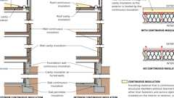
Continuous Insulation
1402.4 Fire Resistance
Diagram
Exterior walls shall be fire-resistance rated as required by other sections of this code with opening protection as required by Chapter 7.
UpCodes Diagrams (2)
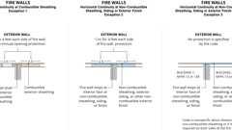
Fire Walls: Horiz. Continuity
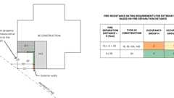
Fire Ratings at Prop. Lines
1402.5 Vertical and Lateral Flame Propagation
Exterior walls on buildings of Type I, II, III and IV construction that contain a combustible exterior wall covering, combustible insulation or a combustible water-resistive barrier shall comply with Sections 1402.5.1 through 1402.5.5, as applicable. Where compliance with NFPA 285 and associated acceptance criteria is required in Sections 1402.5.1 through 1402.5.5, the exterior wall assembly shall be tested in accordance with and comply with the acceptance criteria of NFPA 285.
1402.5.1 Combustible Water-Resistive Barrier
Exterior walls containing a combustible water-resistive barrier shall comply with Section 1402.6.
1402.5.2 Metal Composite Material (MCM)
Exterior walls containing metal composite material (MCM) systems shall comply with Section 1406.
1402.5.3 Exterior Insulation and Finish System (EIFS)
Exterior walls containing an exterior insulation and finish system (EIFS) shall comply with Section 1407.
1402.5.4 High-Pressure Decorative Exterior-Grade Compact Laminate (HPL) System
Exterior walls containing a high-pressure decorative exterior-grade compact laminate (HPL) system shall comply with Section 1408.
1402.5.5 Foam Plastic Insulation
Exterior walls containing foam plastic insulation shall comply with Section 2603.
1402.6 Water-Resistive Barriers
Exterior walls on buildings of Type I, II, III or IV construction that are greater than 40 feet (12 192 mm) in height above grade plane and contain a combustible water-resistive barrier shall be tested in accordance with and comply with the acceptance criteria of NFPA 285.Combustibility shall be determined in accordance with Section 703.3. For the purposes of this section, fenestration products, flashing of fenestration products and water-resistive-barrier flashing and accessories at other locations, including through wall flashings, shall not be considered part of the water-resistive barrier.
Exceptions:
- Exterior walls in which the water-resistive barrier is the only combustible component and the exterior wall has an exterior wall covering of brick, concrete, stone, terra cotta, stucco or steel with minimum thicknesses in accordance with Table 1404.2.
- Exterior walls in which the water-resistive barrier is the only combustible component and the water-resistive barrier complies with the following:
  - A peak heat release rate of less than 150 kW/m², a total heat release of less than 20 MJ/m²and an effective heat of combustion of less than 18 MJ/kg when tested on specimens at the thickness intended for use, in accordance with ASTM E1354, in the horizontal orientation and at an incident radiant heat flux of 50 kW/m².
  - A flame spread index of 25 or less and a smoke-developed index of 450 or less as determined in accordance with ASTM E84 or UL 723, with test specimen preparation and mounting in accordance with ASTM E2404.
1402.7 Exterior Wall Veneers Manufactured Using Combustible Adhesives
Exterior wall assemblies on buildings of Type I, II, III or IV construction that are greater than 40 feet (12 192 mm) in height above grade plane and contain an exterior wall veneer manufactured using a combustible adhesive to laminate a metal core with noncombustible facing materials shall be tested in accordance with, and comply with, the acceptance criteria of NFPA 285, with the adhesive level at the maximum application rate intended for use. Combustibility shall be determined in accordance with Section 703.3.
1402.8 Vertical and Lateral Flame Propagation Compliance Methods
When exterior wall assemblies are required in this chapter to be tested for vertical and lateral flame propagation in accordance with and comply with the acceptance criteria of NFPA 285, compliance with the requirements shall be established by any of the following:
- An exterior wall assembly tested in accordance with and meeting the acceptance criteria of NFPA 285.
- An exterior wall assembly design listed by an approved agency for compliance with NFPA 285.
- An approved analysis based on an assembly or condition tested in accordance with and meeting the acceptance criteria of NFPA 285.
Building products (2)
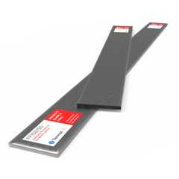
FF102/50 Rainscreen Fireblock
Tenmat

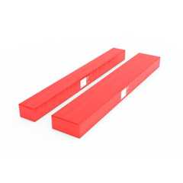
FF102/50Plus Rainscreen Fireblock
Tenmat

[BS] 1402.9 Flood Resistance
Diagram
For buildings in flood hazard areas as established in Section 1612.3, exterior walls extending below the elevation required by Section 1612 shall be constructed with flood-damage-resistant materials.
UpCodes Diagrams (4)
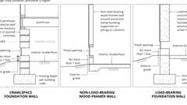
Enclosures with Flood Openings: Zone A
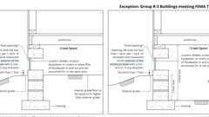
Below Grade Crawlspaces in Zone A (FEMA)
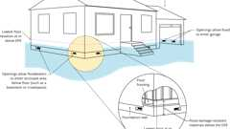
Flood: Wet Floodproofing Garages, Crawlspaces
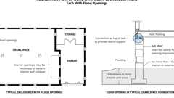
Flood Venting Layout
[BS] 1402.10 Flood Resistance for Coastal High-Hazard Areas and Coastal A Zones
For buildings in coastal high-hazard areas and coastal A zones as established in Section 1612.3, electrical, mechanical and plumbing system components shall not be mounted on or penetrate through exterior walls that are designed to break away under flood loads.
Section 1403 Materials
1403.1 General
Materials used for the construction of exterior walls shall comply with the provisions of this section. Materials not prescribed herein shall be permitted, provided that any such alternative has been approved.
Building products (9)
GreenGirt CMH Clips™
Advanced Architectural Products

GreenGirt CMH Delta™ Adjustable
Advanced Architectural Products

GreenGirt Max CMH™
Advanced Architectural Products

GreenGirt Optima CMH™
Advanced Architectural Products

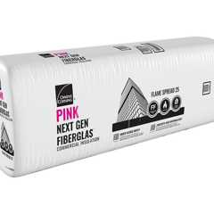
PINK® Next Gen™ Fiberglas™ Flame Spread 25
Owens Corning

SMARTci® (on closed framing)
Advanced Architectural Products

SMARTci® (on open framing)
Advanced Architectural Products

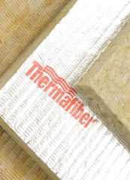
Thermafiber® FireSpan FF
Owens Corning

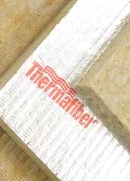
Thermafiber® FireSpan®
Owens Corning

1403.2 Water-Resistive Barrier
Diagram
Not fewer than one layer of water-resistive barrier material shall be attached to the studs or sheathing, with flashing as described in Section 1404.4, in such a manner as to provide a continuous water-resistive barrier behind the exterior wall veneer. The intersection between the water-resistive barrier material and fenestration openings shall be flashed and assembled in accordance with the fenestration manufacturer's installation instructions, or other approved methods for applications not addressed by the fenestration manufacturer's instructions. The water-resistive barrier material shall be continuous to the top of walls and terminated at penetrations and building appendages in a manner to meet the requirements of the exterior wall envelope as described in Section 1402.2.
Water-resistive barriers shall comply with one of the following:
- No. 15 felt complying with ASTM D226, Type 1.
- ASTM E2556, Type I or II.
- Foam plastic insulating sheathing water-resistive barrier systems complying with Section 1402.2 and installed in accordance with manufacturer's installation instructions.
- ASTM E331 in accordance with Section 1402.2.
- Other approved materials installed in accordance with the manufacturer's installation instructions.
No. 15 asphalt felt and water-resistive barriers complying with ASTM E2556 shall be applied horizontally with the upper layer lapped over the lower layer not less than 2 inches (51 mm). Where joints occur, the upper and lower layer shall be lapped not less than 6 inches (152 mm).
UpCodes Diagram (1)
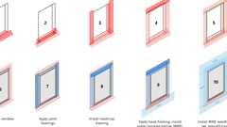
Fenestration Flashing
[BS] 1403.3 Wood
Exterior walls of wood construction shall be designed and constructed in accordance with Chapter 23.
[BS] 1403.3.1 Basic Hardboard
Basic hardboard shall conform to the requirements of ANSI A135.4.
[BS] 1403.3.2 Hardboard Siding
Hardboard siding shall conform to the requirements of ANSI A135.6 and, where used structurally, shall be so identified by the label of an approved agency.
[BS] 1403.4 Masonry
Diagram
Exterior walls of masonry construction shall be designed and constructed in accordance with this section and Chapter 21. Masonry units, mortar and metal accessories used in anchored and adhered veneer shall meet the physical requirements of Chapter 21. The backing of anchored and adhered veneer shall be of concrete, masonry, steel framing or wood framing. Continuous insulation meeting the applicable requirements of this code shall be permitted between the backing and the masonry veneer.
UpCodes Diagram (1)
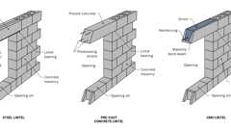
Concrete Masonry Wall Lintel Types
Building products (30)
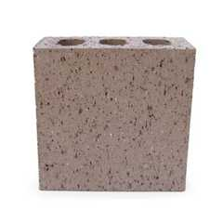
8 Square 4 x 8 x 8
Interstate Brick

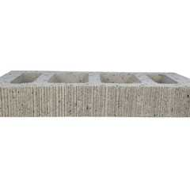
Atlas® 10 x 2¼ x 16
Interstate Brick

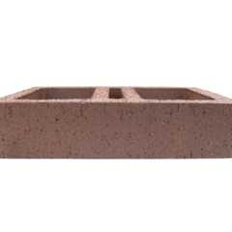
Atlas® 10 x 4 x 16
Interstate Brick

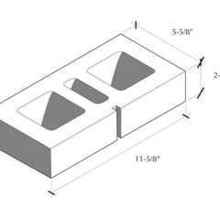
Atlas® 6 x 2¼ x 12
Interstate Brick

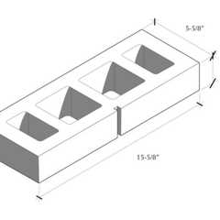
Atlas® 6 x 2¼ x 16
Interstate Brick

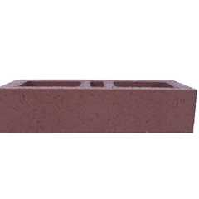
Atlas® 6 x 4 x 16
Interstate Brick

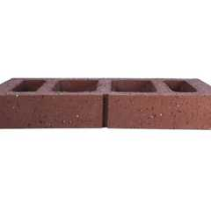
Atlas® 8 x 2¼ x 16
Interstate Brick

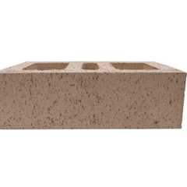
Atlas® 8 x 4 x 12
Interstate Brick

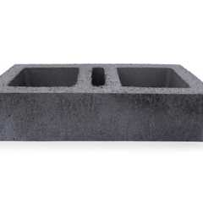
Atlas® 8 x 4 x 16
Interstate Brick

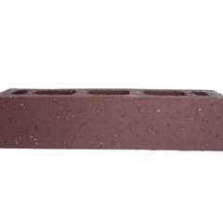
Atlas® Emperor 4 x 4 x 16
Interstate Brick

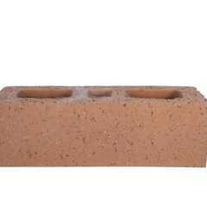
Atlas® Utility 4 x 4 x 12
Interstate Brick

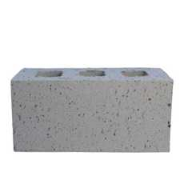
Closure 4 x 4 x 8
Interstate Brick

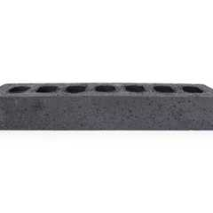
Emperor 4 x 2¼ x 16
Interstate Brick

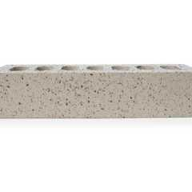
Emperor 4 x 4 x 16
Interstate Brick

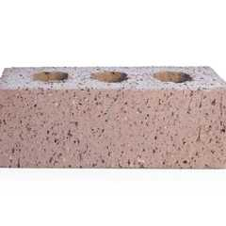
Engineer 4 x 2¾ x 8
Interstate Brick

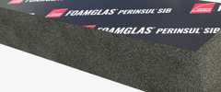
FOAMGLAS® Perinsul® SIB
Owens Corning

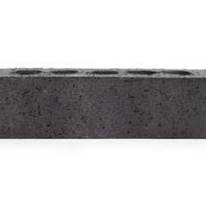
King 3 x 3 x 10
Interstate Brick

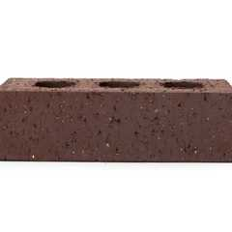
Modular 4 x 2¼ x 8
Interstate Brick

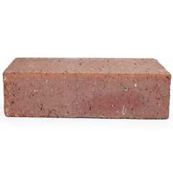
Modular Solid 4 x 2¼ x 8
Interstate Brick

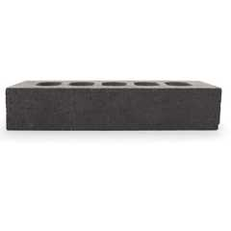
Norman 4 x 2¼ x 12
Interstate Brick

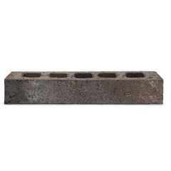
Roman
Interstate Brick

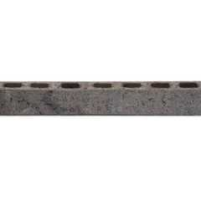
Roman Emperor
Interstate Brick

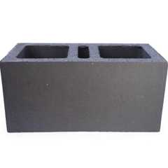
Super Atlas® 8 x 8 x16
Interstate Brick

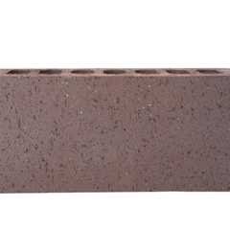
Super Emperor 4 x 8 x 16
Interstate Brick

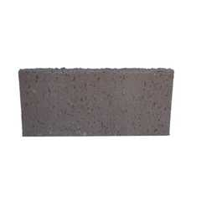
Thin Closure 4 x 8
Interstate Brick

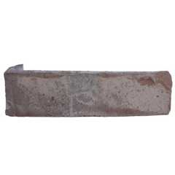
Thin King 3 x 10
Interstate Brick

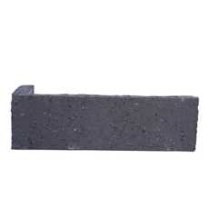
Thin Modular 2¼ x 8
Interstate Brick

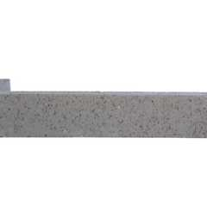
Thin Norman 2¼ x 12
Interstate Brick

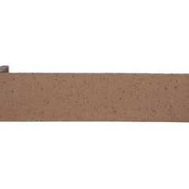
Thin Utility 4 x 12
Interstate Brick

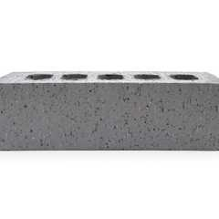
Utility 4 x 4 x 12
Interstate Brick

[BS] 1403.5 Metal
Assembly
Exterior walls constructed of cold-formed or structural steel shall be designed in accordance with Chapter 22. Exterior walls constructed of aluminum shall be designed in accordance with Chapter 20.
Assemblies (2)
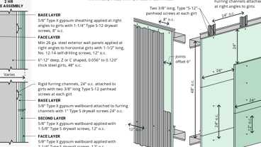
WP 9200; 2hr, Steel Wall Panel / Girts
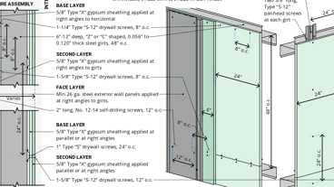
WP 9205; 2hr, Steel Wall Panel / Girts
[BS] 1403.5.1 Aluminum Siding
Aluminum siding shall conform to the requirements of AAMA 1402.
[BS] 1403.5.2 Cold-Rolled Copper
Copper shall conform to the requirements of ASTM B370.
[BS] 1403.5.3 Lead-Coated Copper
Lead-coated copper shall conform to the requirements of ASTM B101.
[BS] 1403.6 Concrete
Exterior walls of concrete construction shall be designed and constructed in accordance with Chapter 19.
[BS] 1403.7 Glass-Unit Masonry
Exterior walls of glass-unit masonry shall be designed and constructed in accordance with Chapter 21.
1403.8 Vinyl Siding
Vinyl siding shall be certified and labeled as conforming to the requirements of ASTM D3679 by an approved agency.
1403.9 Fiber-Cement Siding
Fiber-cement siding shall conform to the requirements of ASTM C1186, Type A (or ISO 8336, Category A), and shall be so identified on labeling listing an approved agency.
1403.10 Exterior Insulation and Finish Systems
Assembly
Exterior insulation and finish systems (EIFS) and exterior insulation and finish systems (EIFS) with drainage shall comply with Section 1407.
Assemblies (3)
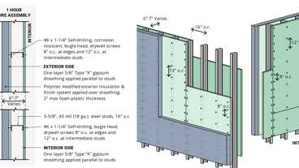
WP 8122: 1hr, Steel Studs, Polymer Mod. EIFS
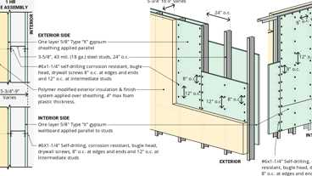
WP 8123; 1hr Steel Studs, Polymer Based EIFS
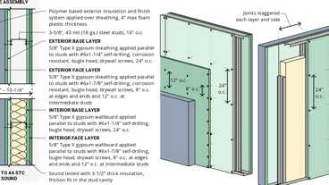
WP 8191: 2hr, 40-44, Steel Stud, Polymer Mod. Ext. Finish
1403.11 Polypropylene Siding
Polypropylene siding shall be certified and labeled as conforming to the requirements of ASTM D7254 and those of Section 1403.11.1 or 1403.11.2 by an approved agency. Polypropylene siding shall be installed in accordance with the requirements of Section 1404.18 and in accordance with the manufacturer's instructions. Polypropylene siding shall be secured to the building so as to provide weather protection for the exterior walls of the building.
1403.11.1 Flame Spread Index
The certification of the flame spread index shall be accompanied by a test report stating that all portions of the test specimen ahead of the flame front remained in position during the test in accordance with ASTM E84 or UL 723.
1403.11.2 Fire Separation Distance
Diagram
The fire separation distance between a building with polypropylene siding and the adjacent building shall be not less than 10 feet (3048 mm).
UpCodes Diagram (1)
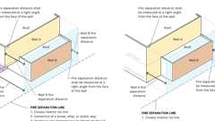
Fire Separation at Story Levels
1403.12 Foam Plastic Insulation
Foam plastic insulation used in exterior wall assemblies shall comply with Chapter 26.
Building products (6)
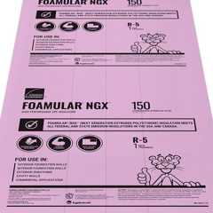
FOAMULAR® NGX® 150
Owens Corning

FOAMULAR® NGX® 250
Owens Corning

GreenGirt CMH Clips™
Advanced Architectural Products

GreenGirt CMH Delta™ Adjustable
Advanced Architectural Products

GreenGirt Max CMH™
Advanced Architectural Products

GreenGirt Optima CMH™
Advanced Architectural Products

1403.13 Fiber-Mat Reinforced Cementitious Backer Units
Fiber-mat reinforced cementitious backer units used as an exterior substrate for the application of exterior finish materials shall comply with ASTM C1325.
1403.14 Insulated Vinyl Siding
Insulated vinyl siding shall be certified and labeled as conforming to the requirements of ASTM D7793 by an approved agency.
Section 1404 Installation of Wall Coverings
Diagram
UpCodes Diagrams (5)
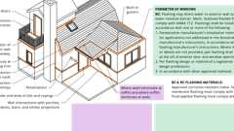
Exterior Wall Flashing (2021)
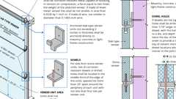
Slab-type Veneer
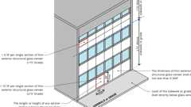
Exterior Glass Veneer
Exterior Envelope: Weather Protection
Fenestration Flashing
Building products (4)
GreenGirt CMH Clips™
Advanced Architectural Products

GreenGirt CMH Delta™ Adjustable
Advanced Architectural Products

GreenGirt Max CMH™
Advanced Architectural Products

GreenGirt Optima CMH™
Advanced Architectural Products

1404.1 General
Exterior wall coverings shall be designed and constructed in accordance with the applicable provisions of this section.
1404.1.1 Soffits and Fascias
Soffits and fascias installed as part of roof overhangs shall comply with Section 1412.
1404.1.2 Additional Requirements
[DSA-SS, DSA-SS/CC, OSHPD 1, 1R, 2, 4 & 5] In addition to the requirements of Section 1404, the installation of anchored or adhered veneer shall comply with applicable provisions of Section 1413.
1404.2 Weather Protection
Assembly
Exterior walls shall provide weather protection for the building. The materials of the minimum nominal thickness specified in Table 1404.2 shall be acceptable as approved weather coverings.
TABLE 1404.2—MINIMUM THICKNESS OF WEATHER COVERINGS
COVERING TYPE | MINIMUM THICKNESS  (inches)
Adhered masonry veneer | 0.25
Aluminum siding | 0.019
Anchored masonry veneer
Stone (natural) | 2.0
Architectural cast stone | 2.5
Other | 2.0
Asbestos-cement boards | 0.125
Asbestos shingles | 0.156
Cold-rolled copper^{d} | 0.0216 nominal
Copper shingles^{d} | 0.0162 nominal
Exterior plywood (with sheathing) | 0.313
Exterior plywood (without sheathing) | See Section 2304.6
Fiber cement lap siding | 0.25^{c}
Fiber cement panel siding | 0.25^{c}
Fiberboard siding | 0.5
Fiber-mat reinforced cementitious backer units | 0.5
Glass-fiber reinforced concrete panels | 0.375
Hardboard siding^{c} | 0.25
High-yield copper^{d} | 0.0162 nominal
Lead-coated copper^{d} | 0.0216 nominal
Lead-coated high-yield copper | 0.0162 nominal
Marble slabs | 1
Particleboard (with sheathing) | See Section 2304.6
Particleboard (without sheathing) | See Section 2304.6
Porcelain tile | 0.125 nominal
Steel (approved corrosion resistant) | 0.0149
Structural glass | 0.344
Stucco or exterior cement plaster
Three-coat work over:
Metal plaster base | 0.875^{b}
Unit masonry | 0.625^{b}
Cast-in-place or precast concrete | 0.625^{b}
Two-coat work over:
Unit masonry | 0.5^{b}
Cast-in-place or precast concrete | 0.375^{b}
Terra cotta (anchored) | 1
Terra cotta (adhered) | 0.25
Vinyl siding | 0.035
Wood shingles | 0.375
Wood siding (without sheathing)ª | 0.5
For SI: 1 inch = 25.4 mm, 1 ounce = 28.35 g, 1 square foot = 0.093 m².
- Wood siding of thicknesses less than 0.5 inch shall be placed over sheathing that conforms to Section 2304.6.
- Exclusive of texture.
- As measured at the bottom of decorative grooves.
- 16 ounces per square foot for cold-rolled copper and lead-coated copper,12 ounces per square foot for copper shingles, high-yield copper and lead-coated high-yield copper.
Assemblies (2)
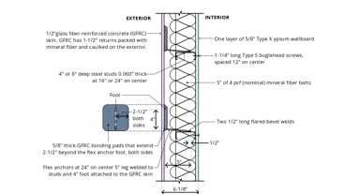
15-1.11: 1hr, Steel Studs w/GFRC
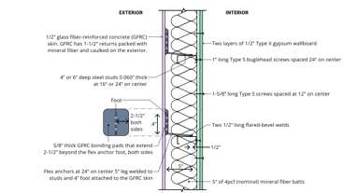
15-1.10: 2hr, Steel Studs w/ GFRC
1404.3 Vapor Retarders
Vapor retarder materials shall be classified in accordance with Table 1404.3(1). A vapor retarder shall be provided on the interior side of frame walls in accordance with Table 1404.3(2) and Tables 1404.3(3) or 1404.3(4) as applicable, or an approved design using accepted engineering practice for hygrothermal analysis. Vapor retarders shall be installed in accordance with Section 1404.3.2. The appropriate climate zone shall be selected in accordance with the California Energy Code.
Exceptions:
- Basement walls.
- Below-grade portion of any wall.
- Construction where accumulation, condensation or freezing of moisture will not damage the materials.
- A vapor retarder shall not be required in Climate Zones 1, 2, and 3.
- In Climate Zones 4 through 8, a vapor retarder on the interior side of frame walls shall not be required where the assembly complies with Table 1404.3(5).
TABLE 1404.3(1)—VAPOR RETARDER MATERIALS AND CLASSES
VAPOR RETARDER CLASS | ACCEPTABLE MATERIALS
I | Sheet polyethylene, nonperforated aluminum foil, or other approved materials with a perm rating of less than or equal to 0.1
II | Kraft-faced fiberglass batts or vapor retarder paint or other approved materials, applied in accordance with the manufacturer's instructions for a perm rating greater than 0.1 and less than or equal to 1.0
III | Latex paint, enamel paint, or other approved materials, applied in accordance with the manufacturer's instructions for a perm rating of greater than 1.0 and less than or equal to 10
TABLE 1404.3(2)—VAPOR RETARDER OPTIONS
CLIMATE ZONE | VAPOR RETARDER CLASS
CLIMATE ZONE | Iª | IIª | III
1, 2 | Not permitted | Not Permitted | Permitted
3 | Not permitted | Permitted^{c} | Permitted
4 (except Marine) | Not permitted | Permitted^{c} | See Table 1404.3(3)
Marine 4, 5, 6, 7, 8 | Permitted^{b, c} | Permitted^{c} | See Table 1404.3(3)
- A responsive vapor retarder shall be allowed on the interior side of any frame wall in all climate zones.
- In frame walls with a Class I vapor retarder on the exterior side, use of a Class I interior vapor retarder that is not a responsive vapor retarder shall require an approved design.
- Where a Class I or II vapor retarder is used in combination with foam plastic insulating sheathing installed as continuous insulation on the exterior side of frame walls, the continuous insulation shall comply with Table 1404.3(4) and the Class I or II vapor retarder shall be a responsive vapor retarder.
TABLE 1404.3(3)—CLASS III VAPOR RETARDERS
ZONE | CLASS III VAPOR RETARDERS PERMITTED FOR:^{a, b}
4 | Vented cladding over wood structural panels  Vented cladding over fiberboard  Vented cladding over gypsum  Continuous insulation with R-value ≥ R-2.5 over 2 × 4 wall  Continuous insulation with R-value ≥ R-3.75 over 2 × 6 wall
5 | Vented cladding over wood structural panels  Vented cladding over fiberboard  Vented cladding over gypsum  Continuous insulation with R-value ≥ R-5 over 2 × 4 wall  Continuous insulation with R-value ≥ R-7.5 over 2 × 6 wall
6 | Vented cladding over fiberboard  Vented cladding over gypsum  Continuous insulation with R-value ≥ R-7.5 over 2 × 4 wall  Continuous insulation with R-value ≥ R-11.25 over 2 × 6 wall
7 | Continuous insulation with R-value ≥ R-10 over 2 × 4 wall  Continuous insulation with R-value ≥ R-15 over 2 × 6 wall
8 | Continuous insulation with R-value ≥ R-12.5 over 2 × 4 wall  Continuous insulation with R-value ≥ R-20 over 2 × 6 wall
- Vented cladding shall include vinyl lap siding, polypropylene, horizontal aluminum siding, brick veneer with airspace as specified in this code, rainscreen systems and other approved vented claddings.
- The requirements in this table apply only to insulation used to control moisture in order to permit the use of Class III vapor retarders. The insulation materials used to satisfy this option also contribute to but do not supersede the building thermal envelope requirements of the California Energy Code.
TABLE 1404.3(4)—CONTINUOUS INSULATION WITH A CLASS I OR II RESPONSIVE VAPOR RETARDER
CLIMATE  ZONE | PERMITTED CONDITIONSª
3 | Continuous insulation with R-value ≥ R-2
4, 5, 6 | Continuous insulation with R-value ≥ R-3 over 2 × 4 wall  Continuous insulation with R-value ≥ R-5 over 2 × 6 wall
7 | Continuous insulation with R-value ≥ R-5 over 2 × 4 wall  Continuous insulation with R-value ≥ R-7.5 over 2 × 6 wall
8 | Continuous insulation with R-value ≥ R-7.5 over 2 × 4 wall  Continuous insulation with R-value ≥ R-10 over 2 × 6 wall
- The requirements in this table apply only to insulation used to control moisture in order to permit the use of Class I or II vapor retarders. The insulation materials used to satisfy this option also contribute to but do not supersede the building thermal envelope requirements of the California Energy Code.
TABLE 1404.3(5)—CONTINUOUS INSULATION ON WALLS WITHOUT A CLASS I, II, OR III INTERIOR VAPOR RETARDERª

CLIMATE ZONE | PERMITTED CONDITIONS^{b,c}
4 | Continuous insulation with R-value ≥ 4.5
5 | Continuous insulation with R-value ≥ 6.5
6 | Continuous insulation with R-value ≥ 8.5
7 | Continuous insulation with R-value ≥ 11.5
8 | Continuous insulation with R-value ≥ 14
- The total insulating value of materials to the interior side of the exterior continuous insulation, including any cavity insulation, shall not exceed R-5. Where the R-value of materials to the interior side of the exterior continuous insulation exceeds R-5, an approved design shall be required.
- A water vapor control material layer having a permeance of not greater than 1 perm in accordance with ASTM E96, Procedure A (dry cup) shall be placed on the exterior side of the wall and to the interior side of the exterior continuous insulation. The exterior continuous insulation shall be permitted to serve as the vapor control layer where, at its installed thickness or with a facer on its interior face, the exterior continuous insulation is a Class I or II vapor retarder.
- The requirements of this table apply only to continuous insulation used to control moisture in order to allow walls without a Class I, II or III interior vapor retarder. The insulation materials used to satisfy this option also contribute to but do not supersede the building thermal envelope requirements of the California Energy Code.
Building products (2)

Pink Next Gen™ Fiberglas™ FastBatt®
Owens Corning

SMARTci® (on closed framing)
Advanced Architectural Products

1404.3.1 Spray Foam Plastic Insulation for Moisture Control With Class II and III Vapor Retarders
For purposes of compliance with Tables 1404.3(3) and 1404.3(4), spray foam with a maximum permeance of 1.5 perms at the installed thickness applied to the interior side of wood structural panels, fiberboard, insulating sheathing or gypsum shall be deemed to meet the continuous insulation moisture control requirement in accordance with one of the following conditions:
- The spray foam R-value meets or exceeds the specified continuous insulation R-value.
- The combined R-value of the spray foam and continuous insulation is equal to or greater than the specified continuous insulation R-value.
1404.3.2 Vapor Retarder Installation
Vapor retarders shall be installed in accordance with the manufacturer's instructions or an approved design. Where a vapor retarder also functions as a component of a continuous air barrier, the vapor retarder shall be installed as an air barrier in accordance with the California Energy Code.
1404.3.3 California Energy Code and International Energy Conservation Code Climate Zones
The IECC climate zones used by this section differ from those used by the California Energy Code to determine applicability of energy efficiency measures. Comparison of IECC and California Energy Code climate zones is shown in Chapter 12, Table 1202.3.1.
1404.4 Flashing
Diagram
Flashing shall be installed in such a manner so as to prevent moisture from entering the exterior wall or to redirect that moisture to the surface of the exterior wall covering or to a water-resistive barrier complying with Section 1403.2 and that is part of a means of drainage complying with Section 1402.2. Flashing shall be installed at the perimeters of exterior door and window assemblies in accordance with Section 1404.4.1, penetrations and terminations of exterior wall assemblies, exterior wall intersections with roofs, chimneys, porches, decks, balconies and similar projections and at built-in gutters and similar locations where moisture could enter the wall. Flashing with projecting flanges shall be installed on both sides and the ends of copings, under sills and continuously above projecting trim. Where self-adhered membranes are used as flashings of fenestration in exterior wall assemblies, those self-adhered flashings shall comply with AAMA 711. Where fluid applied membranes are used as flashing for exterior wall openings, those fluid applied membrane flashings shall comply with AAMA 714.
UpCodes Diagrams (3)
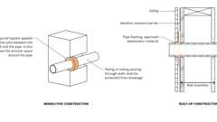Primary
Pipes Penetrating Exterior Walls
Primary
Exterior Wall Flashing (2021)
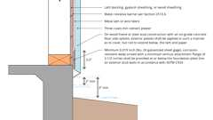
Cement Plaster: Base of Wall
1404.4.1 Fenestration Flashing
Diagram
Flashing of the fenestration to the wall assembly shall comply with the fenestration manufacturer's instructions or, for conditions not addressed by the fenestration manufacturer's instructions, shall comply with one of the following:
- The water-resistive barrier manufacturer's flashing instructions.
- The flashing manufacturer's flashing instructions.
- A flashing design or method of a registered design professional.
- Other approved methods.
UpCodes Diagram (1)
Primary
Fenestration Flashing
1404.4.2 Exterior Wall Pockets
In exterior walls of buildings or structures, wall pockets or crevices in which moisture can accumulate shall be avoided or protected with caps or drips, or other approved means shall be provided to prevent water damage.
1404.4.3 Masonry
Flashing and weep holes in anchored veneer designed in accordance with Section 1404.7 shall be located not more than 10 inches (245 mm) above finished ground level above the foundation wall or slab. At other points of support including structural floors, shelf angles and lintels, flashing and weep holes shall be located in the first course of masonry above the support.
Building products (13)
FOAMGLAS® Perinsul® SIB
Owens Corning

8 Square 4 x 8 x 8
Interstate Brick

Closure 4 x 4 x 8
Interstate Brick

Emperor 4 x 2¼ x 16
Interstate Brick

Emperor 4 x 4 x 16
Interstate Brick

Engineer 4 x 2¾ x 8
Interstate Brick

King 3 x 3 x 10
Interstate Brick

Modular 4 x 2¼ x 8
Interstate Brick

Norman 4 x 2¼ x 12
Interstate Brick

Roman
Interstate Brick

Roman Emperor
Interstate Brick

Super Emperor 4 x 8 x 16
Interstate Brick

Utility 4 x 4 x 12
Interstate Brick

[BS] 1404.5 Fastening
Exterior wall coverings shall be securely fastened with corrosion-resistant fasteners in accordance with this code or the approved manufacturer's instructions. Fastening of claddings or furring through foam plastic insulating sheathing shall comply with Section 1404.5.1, 1404.5.2 or 1404.5.3, as applicable.
Building products (2)
FOAMULAR® NGX® 150
Owens Corning

Thermafiber® RainBarrier® Clip
Owens Corning

[BS] 1404.5.1 Cladding Attachment Over Foam Sheathing to Masonry or Concrete Wall Construction
Cladding shall be specified and installed in accordance with this chapter and the cladding manufacturer's installation instructions or an approved design. Foam sheathing shall be attached to masonry or concrete construction in accordance with the insulation manufacturer's installation instructions or an approved design. Furring and furring attachments through foam sheathing shall be designed to resist design loads determined in accordance with Chapter 16, including support of cladding weight as applicable. Fasteners used to attach cladding or furring through foam sheathing to masonry or concrete substrates shall be approved for application into masonry or concrete material and shall be installed in accordance with the fastener manufacturer's installation instructions.
Exceptions:
- Where the cladding manufacturer has provided approved installation instructions for application over foam sheathing and connection to a masonry or concrete substrate, those requirements shall apply.
- For exterior insulation and finish systems, refer to Section 1407.
- For anchored masonry or stone veneer installed over foam sheathing, refer to Section 1404.
[BS] 1404.5.2 Cladding Attachment Over Foam Sheathing to Cold-Formed Steel Framing
Cladding shall be specified and installed in accordance with this chapter and the cladding manufacturer's approved installation instructions, including any limitations for use over foam plastic sheathing, or an approved design. Where used, furring and furring attachments shall be designed to resist design loads determined in accordance with Chapter 16. In addition, the cladding or furring attachments through foam sheathing to cold-formed steel framing shall meet or exceed the minimum fastening requirements of Sections 1404.5.2.1 and 1404.5.2.2, or an approved design for support of cladding weight.
Exceptions:
- Where the cladding manufacturer has provided approved installation instructions for application over foam sheathing, those requirements shall apply.
- For exterior insulation and finish systems, refer to Section 1407.
- For anchored masonry or stone veneer installed over foam sheathing, refer to Section 1404.
[BS] 1404.5.2.1 Direct Attachment
Where cladding is installed directly over foam sheathing without the use of furring, cladding minimum fastening requirements to support the cladding weight shall be as specified in Table 1404.5.2.1.
[BS] TABLE 1404.5.2.1—CLADDING MINIMUM FASTENING REQUIREMENTS FOR
DIRECT ATTACHMENT OVER FOAM PLASTIC SHEATHING TO SUPPORT CLADDING WEIGHTª
CLADDING FASTENER THROUGH  FOAM SHEATHING INTO: | CLADDING FASTENER TYPE  AND MINIMUM SIZE^{b} | CLADDING  FASTENER  VERTICAL  SPACING  (inches) | MAXIMUM THICKNESS OF FOAM SHEATHING^{c} (inches)
CLADDING FASTENER THROUGH  FOAM SHEATHING INTO: | CLADDING FASTENER TYPE  AND MINIMUM SIZE^{b} | CLADDING  FASTENER  VERTICAL  SPACING  (inches) | 16" o.c. fastener  horizontal spacing |  |  |  | 24" o.c. fastener  horizontal spacing
CLADDING FASTENER THROUGH  FOAM SHEATHING INTO: | CLADDING FASTENER TYPE  AND MINIMUM SIZE^{b} | CLADDING  FASTENER  VERTICAL  SPACING  (inches) | Cladding weight |  |  |  | Cladding weight
CLADDING FASTENER THROUGH  FOAM SHEATHING INTO: | CLADDING FASTENER TYPE  AND MINIMUM SIZE^{b} | CLADDING  FASTENER  VERTICAL  SPACING  (inches) | 3 psf | 11 psf | 18 psf | 25 psf | 3 psf | 11 psf | 18 psf | 25 psf
Cold-formed steel  framing (minimum  penetration of steel  thickness plus  3 threads) | #8 screw into 33 mil  steel or thicker | 6 | 3.00 | 2.95 | 2.20 | 1.45 | 3.00 | 2.35 | 1.25 | DR
 | #8 screw into 33 mil  steel or thicker | 8 | 3.00 | 2.55 | 1.60 | 0.60 | 3.00 | 1.80 | DR | DR
 | #8 screw into 33 mil  steel or thicker | 12 | 3.00 | 1.80 | DR | DR | 3.00 | 0.65 | DR | DR
 | #10 screw into 33 mil  steel | 6 | 4.00 | 3.50 | 2.70 | 1.95 | 4.00 | 2.90 | 1.70 | 0.55
 | #10 screw into 33 mil  steel | 8 | 4.00 | 3.10 | 2.05 | 1.00 | 4.00 | 2.25 | 0.70 | DR
 | #10 screw into 33 mil  steel | 12 | 4.00 | 2.25 | 0.70 | DR | 3.70 | 1.05 | DR | DR
 | #10 screw into  43 mil steel or  thicker | 6 | 4.00 | 4.00 | 4.00 | 3.60 | 4.00 | 4.00 | 3.45 | 2.70
 | #10 screw into  43 mil steel or  thicker | 8 | 4.00 | 4.00 | 3.70 | 3.00 | 4.00 | 3.85 | 2.80 | 1.80
 | #10 screw into  43 mil steel or  thicker | 12 | 4.00 | 3.85 | 2.80 | 1.80 | 4.00 | 3.05 | 1.50 | DR
For SI: 1 inch = 25.4 mm, 1 pound per square foot (psf) = 0.0479 kPa, 1 pound per square inch = 0.00689 MPa.
DR = design required, o.c. = on center.
- Cold-formed steel framing shall be minimum 33 ksi steel for 33 mil and 43 mil steel and 50 ksi steel for 54 mil steel or thicker.
- Screws shall comply with the requirements of AISI S240.
- Foam sheathing shall have a minimum compressive strength of 15 pounds per square inch in accordance with ASTM C578 or ASTM C1289.
[BS] 1404.5.2.2 Furred Cladding Attachment
Where steel or wood furring is used to attach cladding over foam sheathing, furring minimum fastening requirements to support the cladding weight shall be as specified in Table 1404.5.2.2. Where placed horizontally, wood furring shall be preservative-treated wood in accordance with Section 2303.1.9 or naturally durable wood and fasteners shall be corrosion resistant in accordance Section 2304.10.6. Steel furring shall have a minimum G60 galvanized coating.
[BS] TABLE 1404.5.2.2—FURRING MINIMUM FASTENING REQUIREMENTS FOR
APPLICATION OVER FOAM PLASTIC SHEATHING TO SUPPORT CLADDING WEIGHTª

FURRING  MATERIAL | FRAMING  MEMBER | FASTENER  TYPE AND  MINIMUM  SIZE^{b} | MINIMUM  PENETRATION  INTO WALL  FRAMING (inches) | FASTENER  SPACING IN  FURRING  (inches) | MAXIMUM THICKNESS OF FOAM SHEATHING^{d}  (inches)
 |  |  |  |  | 16" o.c. furring^{e} |  |  |  | 24" o.c. furring^{e}
 |  |  |  |  | Cladding weight |  |  |  | Cladding weight
 |  |  |  |  | 3 psf | 11 psf | 18 psf | 25 psf | 3 psf | 11 psf | 18 psf | 25 psf
Minimum 33 mil  steel furring or minimum  1x wood furring^{c} | 33 mil cold-formed  steel stud | #8 screw | Steel thickness plus  3 threads | 12 | 3.00 | 1.80 | DR | DR | 3.00 | 0.65 | DR | DR
 |  |  |  | 16 | 3.00 | 1.00 | DR | DR | 2.85 | DR | DR | DR
 |  |  |  | 24 | 2.85 | DR | DR | DR | 2.20 | DR | DR | DR
 | 33 mil cold-formed  steel stud | #10 screw | Steel thickness plus  3 threads | 12 | 4.00 | 2.25 | 0.70 | DR | 3.70 | 1.05 | DR | DR
 |  |  |  | 16 | 3.85 | 1.45 | DR | DR | 3.40 | DR | DR | DR
 |  |  |  | 24 | 3.40 | DR | DR | DR | 2.70 | DR | DR | DR
 | 43 mil or  thicker cold-formed steel  stud | #8 Screw | Steel thickness plus  3 threads | 12 | 3.00 | 1.80 | DR | DR | 3.00 | 0.65 | DR | DR
 |  |  |  | 16 | 3.00 | 1.00 | DR | DR | 2.85 | DR | DR | DR
 |  |  |  | 24 | 2.85 | DR | DR | DR | 2.20 | DR | DR | DR
 | 43 mil or  thicker cold-formed steel  stud | #10 screw | Steel thickness plus  3 threads | 12 | 4.00 | 3.85 | 2.80 | 1.80 | 4.00 | 3.05 | 1.50 | DR
 |  |  |  | 16 | 4.00 | 3.30 | 1.95 | 0.60 | 4.00 | 2.25 | DR | DR
 |  |  |  | 24 | 4.00 | 2.25 | DR | DR | 4.00 | 0.65 | DR | DR
For SI: 1 inch = 25.4 mm, 1 pound per square foot (psf) = 0.0479 kPa, 1 pound per square inch = 0.00689 MPa.
DR = Design Required, o.c. = on center.
- Wood furring shall be spruce-pine-fir or any softwood species with a specific gravity of 0.42 or greater. Steel furring shall be minimum 33 ksi steel. Cold-formed steel studs shall be minimum 33 ksi steel for 33 mil and 43 mil thickness and 50 ksi steel for 54 mil steel or thicker.
- Screws shall comply with the requirements of AISI S240.
- Where the required cladding fastener penetration into wood material exceeds ³/₄ inch and is not more than 1¹/₂ inches, a minimum 2-inch nominal wood furring or an approved design shall be used.
- Foam sheathing shall have a minimum compressive strength of 15 pounds per square inch in accordance with ASTM C578 or ASTM C1289.
- Furring shall be spaced not more than 24 inches on center, in a vertical or horizontal orientation. In a vertical orientation, furring shall be located over wall studs and attached with the required fastener spacing. In a horizontal orientation, the indicated 8-inch and 12-inch fastener spacing in furring shall be achieved by use of two fasteners into studs at 16 inches and 24 inches on center, respectively.
[BS] 1404.5.3 Cladding Attachment Over Foam Sheathing to Wood Framing
Cladding shall be specified and installed in accordance with this chapter and the cladding manufacturer's installation instructions. Where used, furring and furring attachments shall be designed to resist design loads determined in accordance with Chapter 16. In addition, the cladding or furring attachments through foam sheathing to framing shall meet or exceed the minimum fastening requirements of Section 1404.5.3.1 or 1404.5.3.2, or an approved design for support of cladding weight.
Exceptions:
- Where the cladding manufacturer has provided approved installation instructions for application over foam sheathing, those requirements shall apply.
- For exterior insulation and finish systems, refer to Section 1407.
- For anchored masonry or stone veneer installed over foam sheathing, refer to Section 1404.
[BS] 1404.5.3.1 Direct Attachment
Where cladding is installed directly over foam sheathing without the use of furring, minimum fastening requirements to support the cladding weight shall be as specified in Table 1404.5.3.1.
[BS] TABLE 1404.5.3.1—CLADDING MINIMUM FASTENING REQUIREMENTS FOR
DIRECT ATTACHMENT OVER FOAM PLASTIC SHEATHING TO SUPPORT CLADDING WEIGHTª

CLADDING FASTENER  THROUGH FOAM  SHEATHING INTO: | CLADDING FASTENER TYPE  AND MINIMUM SIZE^{c} | CLADDING  FASTENER  VERTICAL  SPACING  (INCHES) | MAXIMUM THICKNESS OF FOAM SHEATHING^{d}  (INCHES)
CLADDING FASTENER  THROUGH FOAM  SHEATHING INTO: | CLADDING FASTENER TYPE  AND MINIMUM SIZE^{c} | CLADDING  FASTENER  VERTICAL  SPACING  (INCHES) | 16" o.c. fastener horizontal spacing |  |  |  | 24" o.c. fastener horizontal spacing
CLADDING FASTENER  THROUGH FOAM  SHEATHING INTO: | CLADDING FASTENER TYPE  AND MINIMUM SIZE^{c} | CLADDING  FASTENER  VERTICAL  SPACING  (INCHES) | Cladding weight: |  |  |  | Cladding weight:
CLADDING FASTENER  THROUGH FOAM  SHEATHING INTO: | CLADDING FASTENER TYPE  AND MINIMUM SIZE^{c} | CLADDING  FASTENER  VERTICAL  SPACING  (INCHES) | 3 psf | 11 psf | 18 psf | 25 psf | 3 psf | 11 psf | 18 psf | 25 psf
Wood Framing  (minimum 1¹/₄-  inch penetration)^{b} | 0.113"  diameter nail | 6 | 2.00 | 1.45 | 0.75 | DR | 2.00 | 0.85 | DR | DR
Wood Framing  (minimum 1¹/₄-  inch penetration)^{b} | 0.113"  diameter nail | 8 | 2.00 | 1.00 | DR | DR | 2.00 | 0.55 | DR | DR
Wood Framing  (minimum 1¹/₄-  inch penetration)^{b} | 0.113"  diameter nail | 12 | 2.00 | 0.55 | DR | DR | 1.85 | DR | DR | DR
Wood Framing  (minimum 1¹/₄-  inch penetration)^{b} | 0.120"  diameter nail | 6 | 3.00 | 1.70 | 0.90 | 0.55 | 3.00 | 1.05 | 0.50 | DR
Wood Framing  (minimum 1¹/₄-  inch penetration)^{b} | 0.120"  diameter nail | 8 | 3.00 | 1.20 | 0.60 | DR | 3.00 | 0.70 | DR | DR
Wood Framing  (minimum 1¹/₄-  inch penetration)^{b} | 0.120"  diameter nail | 12 | 3.00 | 0.70 | DR | DR | 2.15 | DR | DR | DR
Wood Framing  (minimum 1¹/₄-  inch penetration)^{b} | 0.131" diameter nail | 6 | 4.00 | 2.15 | 1.20 | 0.75 | 4.00 | 1.35 | 0.70 | DR
Wood Framing  (minimum 1¹/₄-  inch penetration)^{b} | 0.131" diameter nail | 8 | 4.00 | 1.55 | 0.80 | DR | 4.00 | 0.90 | DR | DR
Wood Framing  (minimum 1¹/₄-  inch penetration)^{b} | 0.131" diameter nail | 12 | 4.00 | 0.90 | DR | DR | 2.70 | 0.50 | DR | DR
Wood Framing  (minimum 1¹/₄-  inch penetration)^{b} | 0.162"  diameter nail | 6 | 4.00 | 3.55 | 2.05 | 1.40 | 4.00 | 2.25 | 1.25 | 0.80
Wood Framing  (minimum 1¹/₄-  inch penetration)^{b} | 0.162"  diameter nail | 8 | 4.00 | 2.55 | 1.45 | 0.95 | 4.00 | 1.60 | 0.85 | 0.50
Wood Framing  (minimum 1¹/₄-  inch penetration)^{b} | 0.162"  diameter nail | 12 | 4.00 | 1.60 | 0.85 | 0.50 | 4.00 | 0.95 | DR | DR
For SI: 1 inch = 25.4 mm, 1 pound per square foot (psf) = 0.0479 kPa.
DR = Design Required, o.c. = on center.
- Wood framing shall be spruce-pine-fir or any wood species with a specific gravity of 0.42 or greater in accordance with ANSI/AWC NDS.
- The thickness of wood structural panels complying with the specific gravity requirement of Note a shall be permitted to be included in satisfying the minimum penetration into framing.
- Nail fasteners shall comply with ASTM F1667, except nail length shall be permitted to exceed ASTM F1667 standard lengths.
- Foam sheathing shall have a minimum compressive strength of 15 psi in accordance with ASTM C578 or ASTM C1289.
[BS] 1404.5.3.2 Furred Cladding Attachment
Where wood furring is used to attach cladding over foam sheathing, furring minimum fastening requirements to support the cladding weight shall be as specified in Table 1404.5.3.2. Where placed horizontally, wood furring shall be preservative-treated wood in accordance with Section 2303.1.9 or naturally durable wood and fasteners shall be corrosion resistant in accordance with Section 2304.10.6.
[BS] TABLE 1404.5.3.2—FURRING MINIMUM FASTENING REQUIREMENTS FOR
APPLICATION OVER FOAM PLASTIC SHEATHING TO SUPPORT CLADDING WEIGHT^{a, b}
FURRING  MATERIAL | FRAMING  MEMBER | FASTENER  TYPE AND  MINIMUM SIZE | MINIMUM  PENETRATION  INTO WALL  FRAMING  (INCHES)^{c} | FASTENER  SPACING IN  FURRING  (INCHES) | MAXIMUM THICKNESS OF FOAM SHEATHING^{e}  (INCHES)
 |  |  |  |  | 16" o.c. furring^{f} |  |  |  | 24" o.c. furring^{f}
 |  |  |  |  | Siding weight: |  |  |  | Siding weight:
 |  |  |  |  | 3 psf | 11 psf | 18 psf | 25 psf | 3 psf | 11 psf | 18 psf | 25 psf
Minimum  1x Wood Furring^{d} | Minimum  2x Wood Stud | 0.131"  diameter nail | 1¹/₄ | 8 | 4.00 | 2.45 | 1.45 | 0.95 | 4.00 | 1.60 | 0.85 | DR
 |  |  |  | 12 | 4.00 | 1.60 | 0.85 | DR | 4.00 | 0.95 | DR | DR
 |  |  |  | 16 | 4.00 | 1.10 | DR | DR | 3.05 | 0.60 | DR | DR
Minimum  1x Wood Furring^{d} | Minimum  2x Wood Stud | 0.162"  diameter nail | 1¹/₄ | 8 | 4.00 | 4.00 | 2.45 | 1.60 | 4.00 | 2.75 | 1.45 | 0.85
 |  |  |  | 12 | 4.00 | 2.75 | 1.45 | 0.85 | 4.00 | 1.65 | 0.75 | DR
 |  |  |  | 16 | 4.00 | 1.90 | 0.95 | DR | 4.00 | 1.05 | DR | DR
Minimum  1x Wood Furring^{d} | Minimum  2x Wood Stud | No. 10  wood  screw | 1 | 12 | 4.00 | 2.30 | 1.20 | 0.70 | 4.00 | 1.40 | 0.60 | DR
 |  |  |  | 16 | 4.00 | 1.65 | 0.75 | DR | 4.00 | 0.90 | DR | DR
 |  |  |  | 24 | 4.00 | 0.90 | DR | DR | 2.85 | DR | DR | DR
Minimum  1x Wood Furring^{d} | Minimum  2x Wood Stud | 1¹/₄" lag  screw | 1¹/₂ | 12 | 4.00 | 2.65 | 1.50 | 0.90 | 4.00 | 1.65 | 0.80 | DR
 |  |  |  | 16 | 4.00 | 1.95 | 0.95 | 0.50 | 4.00 | 1.10 | DR | DR
 |  |  |  | 24 | 4.00 | 1.10 | DR | DR | 3.25 | 0.50 | DR | DR
For SI: 1 inch = 25.4 mm, 1 pound per square foot (psf) = 0.0479 kPa, 1 pound per square inch = 0.00689 MPa.
DR = Design Required, o.c. = on center.
- Wood framing and furring shall be spruce-pine-fir or any wood species with a specific gravity of 0.42 or greater in accordance with ANSI/AWC NDS.
- Nail fasteners shall comply with ASTM F1667, except nail length shall be permitted to exceed ASTM F1667 standard lengths.
- The thickness of wood structural panels complying with the specific gravity requirements of Note a shall be permitted to be included in satisfying the minimum required penetration into framing.
- Where the required cladding fastener penetration into wood material exceeds ³/₄ inch and is not more than 1¹/₂ inches, a minimum 2-inch nominal wood furring or an approved design shall be used.
- Foam sheathing shall have a minimum compressive strength of 15 psi in accordance with ASTM C578 or ASTM C1289.
- Furring shall be spaced not greater than 24 inches on center in a vertical or horizontal orientation. In a vertical orientation, furring shall be located over wall studs and attached with the required fastener spacing. In a horizontal orientation, the indicated 8-inch and 12-inch fastener spacing in furring shall be achieved by use of two fasteners into studs at 16 inches and 24 inches on center, respectively.
1404.6 Wood Veneers
Diagram
Wood veneers on exterior walls of buildings of Types I, II, III and IV construction shall be not less than 1 inch (25 mm) nominal thickness, 0.438-inch (11.1 mm) exterior hardboard siding or 0.375-inch (9.5 mm) exterior-type wood structural panels or particleboard and shall conform to the following:
- The veneer shall not exceed 40 feet (12 190 mm) in height above grade. Where fire-retardant-treated wood is used, the height shall not exceed 60 feet (18 290 mm) in height above grade.
- The veneer is attached to or furred from a noncombustible backing that is fire-resistance rated as required by other provisions of this code.
- Where open or spaced wood veneers (without concealed spaces) are used, they shall not project more than 24 inches (610 mm) from the building wall.
UpCodes Diagrams (2)
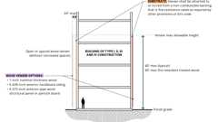Primary
Wood Veneer on Non-Combustible Wall Construction
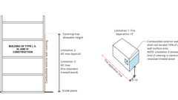
Combustibles on Non-Combustible Ext. Walls: Limitations
[BS] 1404.7 Anchored Masonry Veneer
Assembly
Anchored masonry veneer shall comply with the provisions of Sections 1404.7 through 1404.10 and Sections 13.1 and 13.2 of TMS 402.
Assemblies (2)
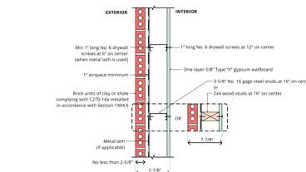
15-2.3: 1hr, Steel or Wood
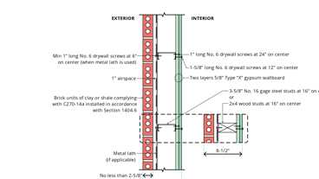
15-2.4: 2hr, Steel or Wood
Building products (13)
FOAMGLAS® Perinsul® SIB
Owens Corning

8 Square 4 x 8 x 8
Interstate Brick

Closure 4 x 4 x 8
Interstate Brick

Emperor 4 x 2¼ x 16
Interstate Brick

Emperor 4 x 4 x 16
Interstate Brick

Engineer 4 x 2¾ x 8
Interstate Brick

King 3 x 3 x 10
Interstate Brick

Modular 4 x 2¼ x 8
Interstate Brick

Norman 4 x 2¼ x 12
Interstate Brick

Roman
Interstate Brick

Roman Emperor
Interstate Brick

Super Emperor 4 x 8 x 16
Interstate Brick

Utility 4 x 4 x 12
Interstate Brick

[BS] 1404.7.1 Tolerances
Anchored masonry veneers in accordance with Chapter 14 are not required to meet the tolerances in Article 3.3 G.1 of TMS 602.
[BS] 1404.8 Stone Veneer
Anchored stone veneer units not exceeding 10 inches (254 mm) in thickness shall be anchored directly to masonry, concrete or to stud construction by one of the following methods:
- With concrete or masonry backing, anchor ties shall be not less than 0.1055-inch (2.68 mm) corrosion-resistant wire, or approved equal, formed beyond the base of the backing. The legs of the loops shall be not less than 6 inches (152 mm) in length bent at right angles and laid in the mortar joint, and spaced so that the eyes or loops are 12 inches (305 mm) maximum on center in both directions. There shall be provided not less than a 0.1055-inch (2.68 mm) corrosion-resistant wire tie, or approved equal, threaded through the exposed loops for every 2 square feet (0.2 m²) of stone veneer. This tie shall be a loop having legs not less than 15 inches (381 mm) in length bent so that the tie will lie in the stone veneer mortar joint. The last 2 inches (51 mm) of each wire leg shall have a right-angle bend. One-inch (25 mm) minimum thickness of cement grout shall be placed between the backing and the stone veneer.
- With wood stud backing, a 2-inch by 2-inch (51 by 51 mm) 0.0625-inch (1.59 mm) zinc-coated or nonmetallic coated wire mesh with two layers of water-resistive barrier in accordance with Section 1403.2 shall be applied directly to wood studs spaced not more than 16 inches (406 mm) on center. On studs, the mesh shall be attached with 2-inch-long (51 mm) corrosion-resistant steel wire furring nails at 4 inches (102 mm) on center providing a minimum 1.125-inch (29 mm) penetration into each stud and with 8d annular threaded nails at 8 inches (203 mm) on center. into top and bottom plates or with equivalent wire ties. There shall be not less than a 0.1055-inch (2.68 mm) zinc-coated or nonmetallic coated wire, or approved equal, attached to the stud with not smaller than an 8d (0.120 in. diameter) annular threaded nail for every 2 square feet (0.2 m²) of stone veneer. This tie shall be a loop having legs not less than 15 inches (381 mm) in length, so bent that the tie will lie in the stone veneer mortar joint. The last 2 inches(51 mm) of each wire leg shall have a right-angle bend.One-inch (25 mm) minimum thickness of cement grout shall be placed between the backing and the stone veneer.
- With cold-formed steel stud backing, a 2-inch by 2-inch (51 by 51 mm) 0.0625-inch (1.59 mm) zinc-coated or nonmetallic coated wire mesh with two layers of water-resistive barrier in accordance with Section 1403.2 shall be applied directly to steel studs spaced a not more than 16 inches (406 mm) on center. The mesh shall be attached with corrosion-resistant #8 self-drilling, tapping screws at 4 inches (102 mm) on center, and at 8 inches (203 mm) on center into top and bottom tracks or with equivalent wire ties. Screws shall extend through the steel connection not fewer than three exposed threads. There shall be not less than a 0.1055-inch (2.68 mm) corrosion-resistant wire, or approved equal, attached to the stud with not smaller than a #8 self-drilling, tapping screw extending through the steel framing not fewer than three exposed threads for every 2 square feet (0.2 m²) of stone veneer. This tie shall be a loop having legs not less than 15 inches (381 mm) in length, so bent that the tie will lie in the stone veneer mortar joint. The last 2 inches (51 mm) of each wire leg shall have a right-angle bend. Cement grout not less than 1 inch (25 mm) in thickness shall be placed between the backing and the stone veneer. The cold-formed steel framing members shall have a minimum bare steel thickness of 0.0428 inches (1.087 mm).
[BS] 1404.9 Slab-Type Veneer
Diagram
Anchored slab-type veneer units not exceeding 2 inches (51 mm) in thickness shall be anchored directly to masonry, concrete or light-frame construction. For veneer units of marble, travertine, granite or other stone units of slab form, ties of corrosion-resistant dowels in drilled holes shall be located in the middle third of the edge of the units, spaced not more than 24 inches (610 mm) apart around the periphery of each unit with not less than four ties per veneer unit. Units shall not exceed 20 square feet (1.9 m²) in area. If the dowels are not tight fitting, the holes shall be drilled not more than 0.063 inch (1.6 mm) larger in diameter than the dowel, with the hole countersunk to a diameter and depth equal to twice the diameter of the dowel in order to provide a tight-fitting key of cement mortar at the dowel locations where the mortar in the joint has set. Veneer ties shall be corrosion-resistant metal capable of resisting, in tension or compression, a force equal to two times the weight of the attached veneer. If made of sheet metal, veneer ties shall be not smaller in area than 0.0336 by 1 inch (0.853 by 25 mm) or, if made of wire, not smaller in diameter than 0.1483-inch (3.76 mm) wire.
UpCodes Diagram (1)
Primary
Slab-type Veneer
Building products (4)
GreenGirt CMH Clips™
Advanced Architectural Products

GreenGirt CMH Delta™ Adjustable
Advanced Architectural Products

GreenGirt Max CMH™
Advanced Architectural Products

GreenGirt Optima CMH™
Advanced Architectural Products

[BS] 1404.10 Terra Cotta
Anchored terra cotta or ceramic units not less than 1⁵/₈ inches (41 mm) thick shall be anchored directly to masonry, concrete or stud construction. Tied terra cotta or ceramic veneer units shall be not less than 1⁵/₈ inches (41 mm) thick with projecting dovetail webs on the back surface spaced approximately 8 inches (203 mm) on center. The facing shall be tied to the backing wall with corrosion-resistant metal anchors of not less than No. 8 gage wire installed at the top of each piece in horizontal bed joints not less than 12 inches (305 mm) nor more than 18 inches (457 mm) on center; these anchors shall be secured to ¹/₄-inch (6.4 mm) corrosion-resistant pencil rods that pass through the vertical aligned loop anchors in the backing wall. The veneer ties shall have sufficient strength to support the full weight of the veneer in tension. The facing shall be set with not less than a 2-inch (51 mm) space from the backing wall and the space shall be filled solidly with Portland cement grout and pea gravel. Immediately prior to setting, the backing wall and the facing shall be drenched with clean water and shall be distinctly damp when the grout is poured.
Building products (4)
GreenGirt CMH Clips™
Advanced Architectural Products

GreenGirt CMH Delta™ Adjustable
Advanced Architectural Products

GreenGirt Max CMH™
Advanced Architectural Products

GreenGirt Optima CMH™
Advanced Architectural Products

[BS] 1404.11 Adhered Masonry Veneer
Assembly
Adhered masonry veneer shall comply with the applicable requirements in this section and Sections 13.1 and 13.2 of TMS 402.
Assemblies (2)
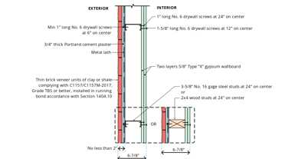
15-2.2: 2hr, Steel or Wood
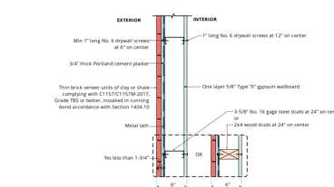
15-2.1: 1hr, Steel or Wood
Building products (9)
GreenGirt CMH Clips™
Advanced Architectural Products

GreenGirt CMH Delta™ Adjustable
Advanced Architectural Products

GreenGirt Max CMH™
Advanced Architectural Products

GreenGirt Optima CMH™
Advanced Architectural Products

Thin Closure 4 x 8
Interstate Brick

Thin King 3 x 10
Interstate Brick

Thin Modular 2¼ x 8
Interstate Brick

Thin Norman 2¼ x 12
Interstate Brick

Thin Utility 4 x 12
Interstate Brick

[BS] 1404.11.1 Exterior Adhered Masonry Veneer
Exterior adhered masonry veneer shall be installed in accordance with Section 1404.11 and the manufacturer's instructions.
[BS] 1404.11.1.1 Water-Resistive Barriers
Water-resistive barriers shall be installed as required in Section 2510.6.
[BS] 1404.11.1.2 Flashing
Flashing shall comply with the applicable requirements of Sections 1404.4 and 1404.11.1.2.1.
[BS] 1404.11.1.2.1 Flashing at Foundation
A corrosion-resistant screed or flashing of a minimum 0.019-inch (0.48 mm) or 26 gage galvanized or plastic with a minimum vertical attachment flange of 3¹/₂ inches (89 mm) shall be installed to extend not less than 1 inch (25 mm) below the foundation plate line on exterior stud walls in accordance with Section 1404.4. The water-resistive barrier shall lap over the exterior of the attachment flange of the screed or flashing.
[BS] 1404.11.1.3 Clearances
On exterior stud walls, adhered masonry veneer shall be installed not less than 4 inches (102 mm) above the earth, or not less than 2 inches (51 mm) above paved areas, or not less than ¹/₂ inch (12.7 mm) above exterior walking surfaces that are supported by the same foundation that supports the exterior wall.
[BS] 1404.11.1.4 Adhered Masonry Veneer Installed With Lath and Mortar
Exterior adhered masonry veneer installed with lath and mortar shall comply with the following.
[BS] 1404.11.1.4.1 Lathing
Lathing shall comply with the requirements of Section 2510.
[BS] 1404.11.1.4.2 Scratch Coat
A nominal ¹/₂-inch-thick (12.7 mm) layer of mortar complying with the material requirements of Sections 2103 and 2512.2 shall be applied, encapsulating the lathing. The surface of this mortar shall be scored horizontally, resulting in a scratch coat.
[BS] 1404.11.1.4.3 Adhering Veneer
The masonry veneer units shall be adhered to the mortar scratch coat with a nominal ¹/₂-inch-thick (12.7 mm) setting bed of mortar complying with Sections 2103 and 2512.2 applied to create a full setting bed for the back of the masonry veneer units. The masonry veneer units shall be worked into the setting bed resulting in a nominal ³/₈-inch (9.5 mm) setting bed after the masonry veneer units are applied.
[BS] 1404.11.1.5 Adhered Masonry Veneer Applied Directly to Masonry and Concrete
Adhered masonry veneer applied directly to masonry or concrete shall comply with the applicable requirements of Section 1404.11 and with the requirements of Section 1404.11.1.4 or 2510.7.
[BS] 1404.11.1.6 Cold Weather Construction
Cold weather construction of adhered masonry veneer shall comply with the requirements of Sections 2104 and 2512.4.
[BS] 1404.11.1.7 Hot Weather Construction
Hot weather construction of adhered masonry veneer shall comply with the requirements of Section 2104.
[BS] 1404.11.2 Exterior Adhered Masonry Veneers Porcelain Tile
Adhered units weighing more than 3.5 pounds per square foot (0.17 kN/m²) shall not exceed 48 inches (1219 mm) in any face dimension nor more than 9 square feet (0.8 m²) in total face area and shall not weigh more than 6 pounds per square foot (0.29 kN/m²). Adhered units weighing less than or equal to 3.5 pounds per square foot (0.17 kN/m²) shall not exceed 72 inches (1829 mm) in any face dimension nor more than 17.5 square feet (1.6 m²) in total face area. Porcelain tile shall be adhered to an approved backing system.
[BS] 1404.11.3 Interior Adhered Masonry Veneers
Interior adhered masonry veneers shall have a maximum weight of 20 psf (0.958 kg/m²) and shall be installed in accordance with Section 1404.11. Where the interior adhered masonry veneer is supported by wood construction, the supporting members shall be designed to limit deflection to ¹/₆₀₀ of the span of the supporting members.
[BS] 1404.12 Metal Veneers
Veneers of metal shall be fabricated from approved corrosion-resistant materials or shall be protected front and back with porcelain enamel, or otherwise be treated to render the metal resistant to corrosion. Such veneers shall be not less than 0.0149-inch (0.378 mm) nominal thickness sheet steel mounted on wood or metal furring strips or approved sheathing on light-frame construction.
Building products (4)
GreenGirt CMH Clips™
Advanced Architectural Products

GreenGirt CMH Delta™ Adjustable
Advanced Architectural Products

GreenGirt Max CMH™
Advanced Architectural Products

GreenGirt Optima CMH™
Advanced Architectural Products

[BS] 1404.12.1 Attachment
Exterior metal veneer shall be securely attached to the supporting masonry or framing members with corrosion-resistant fastenings, metal ties or by other approved devices or methods. The spacing of the fastenings or ties shall not exceed 24 inches (610 mm) either vertically or horizontally, but where units exceed 4 square feet (0.4 m²) in area there shall be not less than four attachments per unit. The metal attachments shall have a cross-sectional area not less than provided by W 1.7 wire. Such attachments and their supports shall be designed and constructed to resist the wind loads as specified in Section 1609 for components and cladding.
1404.12.2 Weather Protection
Metal supports for exterior metal veneer shall be protected by painting, galvanizing or by other equivalent coating or treatment. Wood studs, furring strips or other wood supports for exterior metal veneer shall be approved pressure-treated wood or protected as required in Section 1402.2. Joints and edges exposed to the weather shall be caulked with approved durable waterproofing material or by other approved means to prevent penetration of moisture.
1404.12.3 Backup
Masonry backup shall not be required for metal veneer unless required by the fire-resistance requirements of this code.
1404.12.4 Grounding
Grounding of metal veneers on buildings shall comply with the requirements of Chapter 27 of this code.
[BS] 1404.13 Glass Veneer
Diagram
The area of a single section of thin exterior structural glass veneer shall not exceed 10 square feet (0.93 m²) where that section is not more than 15 feet (4572 mm) above the level of the sidewalk or grade level directly below, and shall not exceed 6 square feet (0.56 m²) where it is more than 15 feet (4572 mm) above that level.
UpCodes Diagram (1)
Primary
Exterior Glass Veneer
[BS] 1404.13.1 Length and Height
The length or height of any section of thin exterior structural glass veneer shall not exceed 48 inches (1219 mm).
[BS] 1404.13.2 Thickness
The thickness of thin exterior structural glass veneer shall be not less than 0.344 inch (8.7 mm).
[BS] 1404.13.3 Application
Diagram
Thin exterior structural glass veneer shall be set only after backing is thoroughly dry and after application of an approved bond coat uniformly over the entire surface of the backing so as to effectively seal the surface. Glass shall be set in place with an approved mastic cement in sufficient quantity so that not less than 50 percent of the area of each glass unit is directly bonded to the backing by mastic not less than ¹/₄ inch (6.4 mm) thick and not more than ⁵/₈ inch (15.9 mm) thick. The bond coat and mastic shall be evaluated for compatibility and shall bond firmly together.
UpCodes Diagram (1)
Exterior Glass Veneer
[BS] 1404.13.4 Installation at Sidewalk Level
Where glass extends to a sidewalk surface, each section shall rest in an approved metal molding, and be set not less than ¹/₄ inch (6.4 mm) above the highest point of the sidewalk. The space between the molding and the sidewalk shall be thoroughly caulked and made watertight.
[BS] 1404.13.4.1 Installation Above Sidewalk Level
Where thin exterior structural glass veneer is installed above the level of the top of a bulkhead facing, or at a level more than 36 inches (914 mm) above the sidewalk level, the mastic cement binding shall be supplemented with approved nonferrous metal shelf angles located in the horizontal joints in every course. Such shelf angles shall be not less than 0.0478-inch (1.2 mm) thick and not less than 2 inches (51 mm) long and shall be spaced at approved intervals, with not less than two angles for each glass unit. Shelf angles shall be secured to the wall or backing with expansion bolts, toggle bolts or by other approved methods.
[BS] 1404.13.5 Joints
Unless otherwise specifically approved by the building official, abutting edges of thin exterior structural glass veneer shall be ground square. Mitered joints shall not be used except where specifically approved for wide angles. Joints shall be uniformly buttered with an approved jointing compound and horizontal joints shall be held to not less than 0.063 inch (1.6 mm) by an approved nonrigid substance or device. Where thin exterior structural glass veneer abuts nonresilient material at sides or top, expansion joints not less than ¹/₄ inch (6.4 mm) wide shall be provided.
[BS] 1404.13.6 Mechanical Fastenings
Thin exterior structural glass veneer installed above the level of the heads of show windows and veneer installed more than 12 feet (3658 mm) above sidewalk level shall, in addition to the mastic cement and shelf angles, be held in place by the use of fastenings at each vertical or horizontal edge, or at the four corners of each glass unit. Fastenings shall be secured to the wall or backing with expansion bolts, toggle bolts or by other methods. Fastenings shall be so designed as to hold the glass veneer in a vertical plane independent of the mastic cement. Shelf angles providing both support and fastenings shall be permitted.
[BS] 1404.13.7 Flashing
Exposed edges of thin exterior structural glass veneer shall be flashed with overlapping corrosion-resistant metal flashing and caulked with a waterproof compound in a manner to effectively prevent the entrance of moisture between the glass veneer and the backing.
1404.14 Exterior Windows and Doors
Diagram
Windows and doors installed in exterior walls shall conform to the testing and performance requirements of Section 1709.5.
UpCodes Diagrams (3)
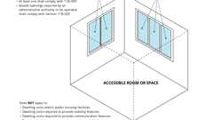
Accessible Windows (CA 11B)
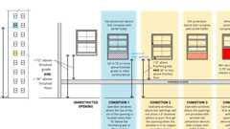
Window Fall Protection
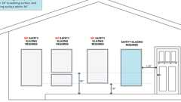
Glazing: Hazardous Locations
Building product (1)
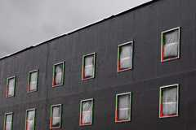
GreenGirt CMH XO™ System
Advanced Architectural Products

1404.14.1 Installation
Windows and doors shall be installed in accordance with approved manufacturer's instructions. Fastener size and spacing shall be provided in such instructions and shall be calculated based on maximum loads and spacing used in the tests.
[BS] 1404.15 Vinyl Siding and Insulated Vinyl Siding
Vinyl siding and insulated vinyl siding conforming to the requirements of this section and complying with ASTM D3679 and ASTM D7793, respectively, shall be permitted on exterior walls where the design wind pressure determined in accordance with Section 1609 does not exceed 30 pounds per square foot (1.44 kN/m²). Where the design wind pressure exceeds 30 pounds per square foot (1.44 kN/m²), tests or calculations indicating compliance with Chapter 16 shall be submitted.
[BS] 1404.15.1 Application
The siding shall be applied over sheathing or materials listed in Section 2304.6. Siding shall be applied to conform to the water-resistive barrier requirements in Section 1402. Siding and accessories shall be installed in accordance with the approved manufacturer's instructions.
[BS] 1404.15.1.1 Fasteners and Fastener Penetration for Wood Construction
Unless otherwise specified in the approved manufacturer's instructions, nails used to fasten the siding and accessories shall be corrosion resistant and have not less than a 0.313-inch (7.9 mm) head diameter and ¹/₈-inch (3.18 mm) shank diameter. The penetration into nailable substrate shall be not less than 1¹/₄ inches (32 mm).
[BS] 1404.15.1.2 Fasteners and Fastener Penetration for Cold-Formed Steel Light-Fame Construction
For cold-formed steel light-frame construction, corrosion-resistant fasteners shall be used. Screw fasteners shall penetrate through the steel with not fewer than three exposed threads. Other fasteners shall be installed in accordance with the approved construction documents and manufacturer's instructions.
[BS] 1404.15.1.3 Fastener Spacing
Unless specified otherwise by the approved manufacturer's instructions, fasteners shall be installed in the middle third of the slots of the nail hem and spacing between fasteners shall be not greater than 16 inches (406 mm) for horizontal siding and 12 inches (305 mm) for vertical siding.
[BS] 1404.15.2 Installation Over Foam Plastic Insulating Sheathing
Where vinyl siding or insulated vinyl siding is installed over foam plastic insulating sheathing, the vinyl siding or insulated vinyl siding shall comply with Section 1404.15 and shall have a wind load design pressure rating in accordance with Table 1404.15.2.
Exceptions:
- Where the foam plastic insulating sheathing is applied directly over wood structural panels, fiberboard, gypsum sheathing or other approved backing capable of independently resisting the design wind pressure, the vinyl siding or insulated vinyl siding shall be installed in accordance with Section 1404.15.1.
- Where the vinyl siding or insulated vinyl siding manufacturer's product specifications provide an approved wind load design pressure rating for installation over foam plastic insulating sheathing, use of this wind load design pressure rating shall be permitted and the siding shall be installed in accordance with the manufacturer's installation instructions.
- Where the foam plastic insulating sheathing and its attachment has a design wind pressure resistance complying with Sections 1609 and 2603.10, the vinyl siding or insulated vinyl siding shall be installed in accordance with Section 1404.15.1.
[BS] TABLE 1404.15.2—REQUIRED MINIMUM WIND LOAD DESIGN PRESSURE
RATING FOR VINYL SIDING INSTALLED OVER FOAM PLASTIC SHEATHING ALONE

ULTIMATE  DESIGN WIND  SPEED (MPH) | ADJUSTED MINIMUM DESIGN WIND PRESSURE (ASD) (PSF)^{a, b}
ULTIMATE  DESIGN WIND  SPEED (MPH) | Case 1: With interior gypsum wallboard^{c} |  |  | Case 2: Without interior gypsum wallboard^{c}
ULTIMATE  DESIGN WIND  SPEED (MPH) | Exposure |  |  | Exposure
ULTIMATE  DESIGN WIND  SPEED (MPH) | B | C | D | B | C | D
≤ 95 | -30.0 | -33.2 | -39.4 | -33.9 | -47.4 | -56.2
100 | -30.0 | -36.8 | -43.6 | -37.2 | -52.5 | -62.2
105 | -30.0 | -40.5 | -48.1 | -41.4 | -57.9 | -68.6
110 | -31.8 | -44.5 | -52.8 | -45.4 | -63.5 | -75.3
115 | -35.5 | -49.7 | -59.0 | -50.7 | -71.0 | -84.2
120 | -37.4 | -52.4 | -62.1 | -53.4 | -74.8 | -88.6
130 | -44.9 | -62.8 | -74.5 | -64.1 | -89.7 | -106
> 130 | See Note d
For SI: 1 inch = 25.4 mm, 1 foot = 304.8 mm, 1 square foot = 0.0929 m, 1 mile per hour = 0.447 m/s, 1 pound per square foot = 0.0479 kPa.
- Linear interpolation is permitted.
- The table values are based on a maximum 30-foot mean roof height, an effective wind area of 10 square feet in Wall Zone 5 (corner), and the ASD design component and cladding wind pressure determined in accordance with Section 1609 multiplied by the following adjustment factors: 1.87 (Case 1) and 2.67 (Case 2).
- Gypsum wallboard, gypsum panel product or equivalent.
- For the indicated wind speed condition and where foam sheathing is the only sheathing on the exterior of a frame wall with vinyl siding, the wall assembly shall be capable of resisting an impact without puncture at least equivalent to that of a wood frame wall with minimum ⁷/₁₆ -inch OSB sheathing as tested in accordance with ASTM E1886. The vinyl siding shall comply with an adjusted design wind pressure requirement in accordance with Note b, using an adjustment factor of 2.67.
[BS] 1404.16 Cement Plaster
Diagram
Cement plaster applied to exterior walls shall conform to the requirements specified in Chapter 25.
UpCodes Diagram (1)
Cement Plaster: Base of Wall
[BS] 1404.17 Fiber-Cement Siding
Fiber-cement siding complying with Section 1403.9 shall be permitted on exterior walls of Types I, II, III, IV and V construction for wind pressure resistance or basic wind speed exposures as indicated by the manufacturer's listing and label and approved installation instructions. Where specified, the siding shall be installed over sheathing or materials listed in Section 2304.6 and shall be installed to conform to the water-resistive barrier requirements in Section 1402. Siding and accessories shall be installed in accordance with approved manufacturer's instructions. Unless otherwise specified in the approved manufacturer's instructions, nails used to fasten the siding to wood studs shall be corrosion-resistant round head smooth shank and shall be long enough to penetrate the studs not less than 1 inch (25 mm). For cold-formed steel light-frame construction, corrosion-resistant fasteners shall be used. Screw fasteners shall penetrate the cold-formed steel framing not fewer than three exposed full threads. Other fasteners shall be installed in accordance with the approved construction documents and manufacturer's instructions.
Building products (4)
GreenGirt CMH Clips™
Advanced Architectural Products

GreenGirt CMH Delta™ Adjustable
Advanced Architectural Products

GreenGirt Max CMH™
Advanced Architectural Products

GreenGirt Optima CMH™
Advanced Architectural Products

[BS] 1404.17.1 Panel Siding
Fiber-cement panels shall comply with the requirements of ASTM C1186, Type A, minimum Grade II (or ISO 8336, Category A, minimum Class 2). Panels shall be installed with the long dimension either parallel or perpendicular to framing. Vertical and horizontal joints shall occur over framing members and shall be protected with caulking, with battens or flashing, or be vertical or horizontal shiplap or otherwise designed to comply with Section 1402.2. Panel siding shall be installed with fasteners in accordance with the approved manufacturer's instructions.
[BS] 1404.17.2 Lap Siding
Fiber-cement lap siding having a maximum width of 12 inches (305 mm) shall comply with the requirements of ASTM C1186, Type A, minimum Grade II (or ISO 8336, Category A, minimum Class 2). Lap siding shall be lapped not less than 1¹/₄ inches (32 mm) and lap siding not having tongue-and-groove end joints shall have the ends protected with caulking, covered with an H-section joint cover, located over a strip of flashing or shall be otherwise designed to comply with Section 1402.2. Lap siding courses shall be installed with the fastener heads exposed or concealed in accordance with the approved manufacturer's instructions.
[BS] 1404.18 Polypropylene Siding
Polypropylene siding conforming to the requirements of this section and complying with Section 1403.11 shall be limited to exterior walls located in areas where the basic wind speed, V, specified in Chapter 16 does not exceed 100 miles per hour (45 m/s) and the building height is less than or equal to 40 feet (12 192 mm) in Exposure C. Where construction is located in areas where the basic wind speed, V, exceeds 100 miles per hour (45 m/s), or building heights are in excess of 40 feet (12 192 mm), tests or calculations indicating compliance with Chapter 16 shall be submitted.
[BS] 1404.18.1 Installation
Polypropylene siding and accessories shall be installed over and attached to wood structural panel sheathing with nailable substrate not less than ⁷/₁₆ inch (11.1 mm) in thickness or other substrate suitable for mechanical fasteners in accordance with the approved manufacturer's instructions.
[BS] 1404.18.2 Fastener Requirements
Unless otherwise specified in the approved manufacturer's instructions, nails shall be corrosion resistant, with a minimum 0.120-inch (3 mm) shank and a minimum 0.313-inch (8 mm) head diameter. Nails shall be not less than 1 ¹/₄ inches (32 mm) long or as necessary to penetrate sheathing or nailable substrate not less than ³/₄ inch (19.1 mm). Where the nail fully penetrates the sheathing or nailable substrate, the end of the fastener shall extend not less than ¹/₄ inch (6.4 mm) beyond the opposite face of the sheathing or nailable substrate. Spacing of fasteners shall be installed in accordance with the approved manufacturer's instructions.
[BS] 1404.19 Fiber-Mat Reinforced Cementitious Backer Units
Fiber-mat reinforced cementitious backer units shall be permitted on exterior walls and shall meet the requirements of Section 1404.19.1.
[BS] 1404.19.1 Installation
Installation of fiber-mat reinforced cementitious backer units used as an exterior substrate for the application of exterior finish materials shall be in accordance with backer unit manufacturer's installation instructions. Panels shall be installed using corrosion-resistant fasteners. Finish materials shall be installed in accordance with approved finish material manufacturer's instructions.
Section 1405 Combustible Materials on the Exterior Side of Exterior Walls
Diagram
UpCodes Diagrams (5)
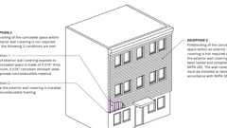
Fireblocking: Ext. Wall Coverings, Excpt. 2 & 3
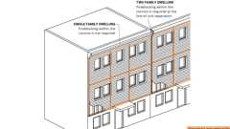
Fireblocking: Ext. Wall Coverings, Excpt. 1
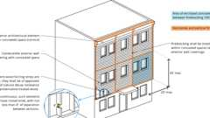
Fireblocking: Exterior Wall Coverings
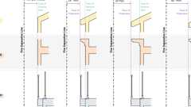
Exterior Wall Projections
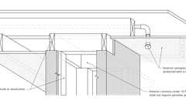
Concealed Spaces: Ext. Framed Columns (NFPA 13)
Building products (2)
FF102/50 Rainscreen Fireblock
Tenmat

FF102/50Plus Rainscreen Fireblock
Tenmat

1405.1 Combustible Exterior Wall Coverings
Combustible exterior wall coverings shall comply with this section.
Exception: Plastics complying with Chapter 26.
1405.1.1 Types I, II, III and IV-HT Construction
Diagram
On buildings of Types I, II, III and IV-HT construction, exterior wall coverings shall be permitted to be constructed of combustible materials, complying with the following limitations:
- Combustible exterior wall coverings shall not exceed 10 percent of an exterior wall surface area where the fire separation distance is 5 feet (1524 mm) or less.
- Combustible exterior wall coverings shall be limited to 40 feet (12 192 mm) in height above grade plane.
Exceptions:
  - Metal composite material (MCM) systems complying with Section 1406.
  - Exterior insulation and finish systems (EIFS) complying with Section 1407.
  - High-pressure decorative exterior-grade compact laminate (HPL) systems complying with Section 1408.
  - Exterior wall coverings containing foam plastic insulation complying with Section 2603.
- Combustible exterior wall coverings constructed of fire-retardant-treated wood complying with Section 2303.2 for exterior installation shall not be limited in wall surface area where the fire separation distance is 5 feet (1524 mm) or less and shall be permitted up to 60 feet (18 288 mm) in height above grade plane regardless of the fire separation distance.
- Wood veneers shall comply with Section 1404.6.
UpCodes Diagrams (3)
Primary
Combustibles on Non-Combustible Ext. Walls: Limitations
Wood Veneer on Non-Combustible Wall Construction
Fire Separation at Story Levels
1405.1.1.1 Ignition Resistance
Where permitted by Section 1405.1.1, combustible exterior wall coverings shall be tested in accordance with NFPA 268.
Exceptions:
- Wood or wood-based products.
- Other combustible materials covered with an exterior weather covering, other than vinyl sidings, included in and complying with the thickness requirements of Table 1404.2.
- Aluminum having a minimum thickness of 0.019 inch (0.48 mm).
1405.1.1.1.1 Fire Separation 5 Feet or Less
Diagram
Where installed on exterior walls having a fire separation distance of 5 feet (1524 mm) or less, combustible exterior wall coverings shall not exhibit sustained flaming as defined in NFPA 268.
UpCodes Diagram (1)
Fire Separation at Story Levels
1405.1.1.1.2 Fire Separation Greater Than 5 Feet
Diagram
For fire separation distances greater than 5 feet (1524 mm), any exterior wall covering shall be permitted that has been exposed to a reduced level of incident radiant heat flux in accordance with the NFPA 268 test method without exhibiting sustained flaming. The minimum fire separation distance required for the exterior wall covering shall be determined from Table 1405.1.1.1.2 based on the maximum tolerable level of incident radiant heat flux that does not cause sustained flaming of the exterior wall covering.
TABLE 1405.1.1.1.2—MINIMUM FIRE SEPARATION FOR COMBUSTIBLE EXTERIOR WALL COVERINGS
FIRE SEPARATION DISTANCE  (feet) | TOLERABLE LEVEL INCIDENT  RADIANT HEAT ENERGY (kW/m²)
5 | 12.5
6 | 11.8
7 | 11.0
8 | 10.3
9 | 9.6
10 | 8.9
11 | 8.3
12 | 7.7
13 | 7.2
14 | 6.7
15 | 6.3
16 | 5.9
17 | 5.5
18 | 5.2
19 | 4.9
20 | 4.6
21 | 4.4
22 | 4.1
23 | 3.9
24 | 3.7
25 | 3.5
For SI: 1 foot = 304.8 mm, 1 Btu/H² × °F = 0.0057 kW/m² × K.
UpCodes Diagram (1)
Fire Separation at Story Levels
1405.1.2 Location
Combustible exterior wall coverings located along the top of exterior walls shall be completely backed up by the exterior wall and shall not extend over or above the top of the exterior wall.
1405.1.3 Fireblocking
Diagram
Where the combustible exterior wall covering is furred out from the exterior wall and forms a solid surface, the distance between the back of the exterior wall covering and the exterior wall shall not exceed 1⁵/₈ inches (41 mm). The concealed space thereby created shall be fireblocked in accordance with Section 718.
Exception: The distance between the back of the exterior wall covering and the exterior wall shall be permitted to exceed 1⁵/₈ inches (41 mm) where the concealed space is not required to be fireblocked by Section 718.
UpCodes Diagrams (4)
Fireblocking: Ext. Wall Coverings, Excpt. 2 & 3
Fireblocking: Ext. Wall Coverings, Excpt. 1
Fireblocking: Exterior Wall Coverings
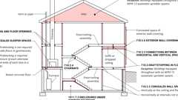
Fireblocking, Draftstopping and Enclosed Space Concepts
Building products (2)
FF102/50 Rainscreen Fireblock
Tenmat

FF102/50Plus Rainscreen Fireblock
Tenmat

Section 1406 Metal Composite Material (MCM)
1406.1 General
The provisions of this section shall govern the materials, construction and quality of metal composite material (MCM) for use as exterior wall coverings in addition to other applicable requirements of Chapters 14 and 16.
1406.2 Exterior Wall Covering
Diagram
MCM used as exterior wall covering or as elements of balconies and similar projections and bay and oriel windows to provide cladding or weather resistance shall comply with Sections 1406.4 through 1406.13.
UpCodes Diagram (1)
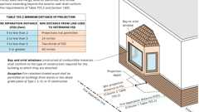
Bay and Oriel Windows
1406.3 Architectural Trim and Embellishments
MCM used as architectural trim or embellishments shall comply with Sections 1406.7 through 1406.13.
[BS] 1406.4 Structural Design
MCM systems shall be designed and constructed to resist wind loads as required by Chapter 16 for components and cladding.
Building products (4)
GreenGirt CMH Clips™
Advanced Architectural Products

GreenGirt CMH Delta™ Adjustable
Advanced Architectural Products

GreenGirt Max CMH™
Advanced Architectural Products

GreenGirt Optima CMH™
Advanced Architectural Products

1406.5 Approval
Results of approved tests or an engineering analysis shall be submitted to the building official to verify compliance with the requirements of Chapter 16 for wind loads.
1406.6 Weather Resistance
MCM systems shall comply with Section 1402 and shall be designed and constructed to resist wind and rain in accordance with this section and the manufacturer's installation instructions.
1406.7 Durability
MCM systems shall be constructed of approved materials that maintain the performance characteristics required in Section 1406 for the duration of use.
1406.8 Fire-Resistance Rating
Where MCM systems are used on exterior walls required to have a fire-resistance rating in accordance with Section 705, evidence shall be submitted to the building official that the required fire-resistance rating is maintained.
Exception: MCM systems that are part of an exterior wall assembly not containing foam plastic insulation and are installed on the outer surface of a fire-resistance-rated exterior wall in a manner such that the attachments do not penetrate through the entire exterior wall assembly, shall not be required to comply with this section.
1406.9 Surface-Burning Characteristics
Unless otherwise specified, MCM shall have a flame spread index of 75 or less and a smoke-developed index of 450 or less when tested in the maximum thickness intended for use in accordance with ASTM E84 or UL 723.
1406.10 Types I, II, III and IV Construction
Where installed on buildings of Types I, II, III and IV construction, metal composite material (MCM) shall comply with Sections 1406.10.1 and 1406.10.2 for installations up to 40 feet (12 192 mm) above grade plane. Where installed on buildings of Type I, II, III and IV construction, MCMs and MCM systems shall comply with Sections 1406.10.1 through 1406.10.3, for installations greater than 40 feet (12 192 mm) above grade plane.
1406.10.1 Surface-Burning Characteristics
MCM shall have a flame spread index of not more than 25 and a smoke-developed index of not more than 450 when tested in the maximum thickness intended for use in accordance with ASTM E84 or UL 723.
1406.10.2 Thermal Barriers
MCM shall be separated from the interior of a building by an approved thermal barrier consisting of ¹/₂-inch (12.7 mm) gypsum wallboard or material that is tested in accordance with and meets the acceptance criteria of both the Temperature Transmission Fire Test and the Integrity Fire Test of NFPA 275.
Exceptions:
- The MCM system is specifically approved based on tests conducted in accordance with NFPA 286 and with the acceptance criteria of Section 803.1.1.1, UL 1040 or UL 1715. Such testing shall be performed with the MCM in the maximum thickness intended for use. The MCM system shall include seams, joints and other typical details used in the installation and shall be tested in the manner intended for use.
- The MCM is used as elements of balconies and similar projections, architectural trim or embellishments.
1406.10.3 Full-Scale Tests
The MCM system shall be tested in accordance with, and comply with, the acceptance criteria of NFPA 285. Such testing shall be performed on the MCM system with the MCM in the maximum thickness intended for use.
1406.11 Type V Construction
MCM shall be permitted to be installed on buildings of Type V construction.
1406.12 Foam Plastic Insulation
Where MCM systems are included in an exterior wall assembly containing foam plastic insulation, the exterior wall assembly shall also comply with the requirements of Section 2603.
1406.13 Labeling
MCM shall be labeled in accordance with Section 1703.5.
Section 1407 Exterior Insulation and Finish Systems (EIFS)
Assembly
Assemblies (2)
WP 8122: 1hr, Steel Studs, Polymer Mod. EIFS
WP 8123; 1hr Steel Studs, Polymer Based EIFS
1407.1 General
The provisions of this section shall govern the materials, construction and quality of exterior insulation and finish systems (EIFS) for use as exterior wall coverings in addition to other applicable requirements of Chapters 7, 14, 16, 17 and 26.
1407.2 Performance Characteristics
EIFS shall be constructed such that it meets the performance characteristics required in ASTM E2568.
[BS] 1407.3 Structural Design
The underlying structural framing and substrate shall be designed and constructed to resist loads as required by Chapter 16.
1407.4 Weather Resistance
EIFS shall comply with Section 1402 and shall be designed and constructed to resist wind and rain in accordance with this section and the manufacturer's application instructions.
1407.4.1 EIFS With Drainage
EIFS with drainage shall have an average minimum drainage efficiency of 90 percent when tested in accordance the requirements of ASTM E2273 and is required on framed walls of Type V construction, Group R1, R2, R3 and R4 occupancies.
1407.4.1.1 Water-Resistive Barrier
For EIFS with drainage, the water-resistive barrier shall comply with Section 1403.2 or ASTM E2570.
1407.5 Exterior Walls of Buildings of Any Height
Exterior wall assemblies containing an EIFS exterior wall covering shall comply with Section 2603.5.
1407.6 Installation
Installation of the EIFS and EIFS with drainage shall be in accordance with the EIFS manufacturer's instructions.
1407.7 Special Inspections
EIFS installations shall comply with the provisions of Sections 1704.2 and 1705.17.
Section 1408 High-Pressure Decorative Exterior-Grade Compact Laminates (HPL)
1408.1 General
The provisions of this section shall govern the materials, construction and quality of High-Pressure Decorative Exterior-Grade Compact Laminates (HPL) for use as exterior wall coverings in addition to other applicable requirements of Chapters 14 and 16.
1408.2 Exterior Wall Covering
Diagram
HPL used as exterior wall covering or as elements of balconies and similar projections and bay and oriel windows to provide cladding or weather resistance shall comply with Sections 1408.4 through 1408.14.
UpCodes Diagram (1)
Bay and Oriel Windows
1408.3 Architectural Trim and Embellishments
HPL used as architectural trim or embellishments shall comply with Sections 1408.7 through 1408.14.
[BS] 1408.4 Structural Design
HPL systems shall be designed and constructed to resist wind loads as required by Chapter 16 for components and cladding.
Building products (4)
GreenGirt CMH Clips™
Advanced Architectural Products

GreenGirt CMH Delta™ Adjustable
Advanced Architectural Products

GreenGirt Max CMH™
Advanced Architectural Products

GreenGirt Optima CMH™
Advanced Architectural Products

1408.5 Approval
Results of approved tests or an engineering analysis shall be submitted to the building official to verify compliance with the requirements of Chapter 16 for wind loads.
1408.6 Weather Resistance
HPL systems shall comply with Section 1402 and shall be designed and constructed to resist wind and rain in accordance with this section and the manufacturer's instructions.
1408.7 Durability
HPL systems shall be constructed of approved materials that maintain the performance characteristics required in Section 1408 for the duration of use.
1408.8 Fire-Resistance Rating
Where HPL systems are used on exterior walls required to have a fire-resistance rating in accordance with Section 705, evidence shall be submitted to the building official that the required fire-resistance rating is maintained.
Exception: HPL systems not containing foam plastic insulation, which are installed on the outer surface of a fire-resistance-rated exterior wall in a manner such that the attachments do not penetrate through the entire exterior wall assembly, shall not be required to comply with this section.
1408.9 Surface-Burning Characteristics
Unless otherwise specified, HPL shall have a flame spread index of 75 or less and a smoke-developed index of 450 or less when tested in the minimum and maximum thicknesses intended for use in accordance with ASTM E84 or UL 723.
1408.10 Types I, II, III and IV Construction
Where installed on buildings of Types I, II, III and IV construction, HPL systems shall comply with Sections 1408.10.1 through 1408.10.4, or Section 1408.11.
1408.10.1 Surface-Burning Characteristics
HPL shall have a flame spread index of not more than 25 and a smoke-developed index of not more than 450 when tested in the minimum and maximum thicknesses intended for use in accordance with ASTM E84 or UL 723.
1408.10.2 Thermal Barriers
HPL shall be separated from the interior of a building by an approved thermal barrier consisting of ¹/₂-inch (12.7 mm) gypsum wallboard or a material that is tested in accordance with and meets the acceptance criteria of both the Temperature Transmission Fire Test and the Integrity Fire Test of NFPA 275.
1408.10.3 Thermal Barrier Not Required
The thermal barrier specified for HPL in Section 1408.10.2 is not required where:
- The HPL system is specifically approved based on tests conducted in accordance with NFPA 286, and with the acceptance criteria of Section 803.1.1.1, or with UL 1040 or UL 1715. Such testing shall be performed with the HPL in the minimum and maximum thicknesses intended for use. The HPL system shall include seams, joints and other typical details used in the installation and shall be tested in the manner intended for use.
- The HPL is used as elements of balconies and similar projections, architectural trim or embellishments.
1408.10.4 Full-Scale Tests
The HPL system shall be tested in accordance with, and comply with, the acceptance criteria of NFPA 285. Such testing shall be performed on the HPL system with the HPL in the minimum and maximum thicknesses intended for use.
1408.11 Alternate Conditions
HPL and HPL systems shall not be required to comply with Sections 1408.10.1 through 1408.10.4 provided that such systems comply with Section 1408.11.1.
1408.11.1 Installations Up to 40 Feet in Height
Diagram
HPL shall be permitted to be installed up to 40 feet (12 190 mm) in height above grade plane where installed in accordance with Section 1408.11.1.1 or 1408.11.1.2.
UpCodes Diagram (1)
Fire Separation at Story Levels
1408.11.1.1 Fire Separation Distance of 5 Feet or Less
Where the fire separation distance is 5 feet (1524 mm) or less, the area of HPL shall not exceed 10 percent of the exterior wall surface.
1408.11.1.2 Fire Separation Distance Greater Than 5 Feet
Where the fire separation distance is greater than 5 feet (1524 mm), the area of exterior wall surface coverage using HPL shall not be limited.
1408.12 Type V Construction
HPL shall be permitted to be installed on buildings of Type V construction.
1408.13 Foam Plastic Insulation
HPL systems containing foam plastic insulation shall comply with the requirements of Section 2603.
1408.14 Labeling
HPL shall be labeled in accordance with Section 1703.5.
Section 1409 Insulated Metal Panel (IMP)
1409.1 General
The provisions of this section, in addition to the other applicable requirements of this chapter and Chapter 16, shall govern the materials, construction and quality of insulated metal panels (IMP) for use as exterior walls and exterior wall coverings.
1409.2 Structural Design
Structural design of IMP systems shall be in accordance with this section.
1409.2.1 IMP Systems Used as Exterior Walls
IMP systems used as exterior walls shall be designed and constructed to resist design loads in accordance with applicable provisions of Chapter 16.
1409.2.2 IMP Systems Used as Exterior Wall Coverings
IMP systems used as exterior wall covering systems shall be designed and constructed to resist wind loads as required by Section 1609.
1409.2.3 Approval
Results of approved tests or engineering analyses shall be submitted to the building official to verify compliance with the applicable requirements of Chapter 16.
1409.3 Weather Resistance
IMP systems shall comply with Section 1402 and shall be designed and constructed to resist wind and rain in accordance with this section and the manufacturer's installation instructions.
1409.4 Durability
IMP systems shall be constructed of approved materials that maintain the performance characteristics required in Section 1402 for the duration of use.
1409.5 Fire-Resistance Rating
Evidence of the required fire-resistance rating of IMP systems shall be in accordance with this section.
1409.5.1 IMP Used as Exterior Walls
In all types of construction where IMP systems are used as exterior walls required to have a fire-resistance rating in accordance with Section 705, evidence shall be submitted to the building official that the wall achieves the required fire-resistance rating.
1409.5.2 IMP Used as Exterior Wall Coverings
In all types of construction where IMP systems are used as exterior wall coverings on exterior walls required to have a fire-resistance rating in accordance with Section 705, evidence shall be submitted to the building official that the required fire-resistance rating is maintained.
Exception: IMP systems not containing combustible insulation, which are installed on the outer surface of a fire-resistance rated exterior wall in a manner such that the attachments do not penetrate to the entire exterior wall assembly.
1409.6
IMP systems with noncombustible core insulation. IMP with noncombustible core insulation shall comply with Sections 1409.1 through 1409.5. Combustibility shall be determined in accordance with Section 703.3.
1409.7 IMP Systems With Combustible Core Insulation
IMP systems with combustible core insulation shall comply with Sections 1409.1 through 1409.5 and this section. Combustibility shall be determined in accordance with Section 703.3.
1409.7.1 Surface-Burning Characteristics
Unless otherwise specified in this section, a combustible core 4 inches (102 mm) or less in thickness shall have a flame spread index of 75 or less and a smoke-developed index of 450 or less when tested in the maximum thickness intended for use in accordance with ASTM E84 or UL 723. For thicknesses greater than 4 inches (102 mm), the combustible core shall have a flame spread index of 75 or less and a smoke-developed index of 450 or less at 4 inches (102 mm) in thickness and the IMP approved based on testing in accordance with Section 1409.7.2.2 at the maximum IMP thickness intended for use.
1409.7.1.1 Foam Plastic Core
For IMP having a core insulation composed of foam plastic, the insulation core shall comply with Section 2603.3.
1409.7.2 Thermal Barrier
Unless otherwise specified in this section, IMP with a combustible core shall be separated from the interior of a building by an approved thermal barrier consisting of 1/2-inch (12.7 mm) gypsum wallboard or a material that is tested in accordance with and meets the acceptance criteria of both the Temperature Transmission Fire Test and the Integrity Fire Test of NFPA 275.
1409.7.2.1 Foam Plastic Core
For IMP having a foam plastic core, use with the thermal barrier prescribed in Section 1409.7.2 shall be in accordance with Section 2603.4 unless special approval is obtained on the basis of Section 2603.9.
1409.7.2.2 Special Approval
The thermal barrier specified in Section 1409.7.2 is not required where IMP is specifically approved based on tests conducted in accordance with, but not limited to, NFPA 286 (with the acceptance criteria of Section 803.1.1.1), FM 4880 or UL 1715. Such testing shall be performed with the IMP in a configuration related to the actual end-use and at the maximum thickness intended for use, and shall include seams, factory joints, sealants and other typical details intended for use.
1409.7.3 Type I, II, III, and IV Construction
Where used as exterior walls or as exterior wall coverings on buildings of Type I, II, III and IV construction, IMP systems shall comply with this section as follows:
- IMP having a foam plastic core shall comply with Section 2603.5.
- IMP having combustible core other than foam plastic shall comply with Sections 1409.7.3.1 through 1409.7.3.4.
1409.7.3.1 Surface-Burning Characteristics
A combustible core not greater than 4 inches (102 mm) in thickness shall have a flame spread index of 25 or less and a smoke-developed index of 450 or less when tested in the maximum thickness intended for use in accordance with ASTM E84 or UL 723. For thicknesses greater than 4 inches (102 mm) the combustible core shall have a flame spread index of 75 or less and a smoke-developed index of 450 or less at 4 inches (102 mm) in thickness and the IMP approved based on testing in accordance with Section 1409.7.2.2 at the maximum IMP thickness intended for use.
1409.7.3.2 Thermal Barrier
IMP shall be separated from the interior of a building by an approved thermal barrier in accordance with Section 1409.7.2.
1409.7.3.3 Vertical and Lateral Flame Propagation
IMP installations greater than 40 feet (12 192 mm) in height above grade plane shall be tested in accordance with and comply with the acceptance criteria of NFPA 285. Such testing shall be performed on the exterior wall assembly and with the IMP in the maximum thickness intended for use.
1409.7.3.4 Ignition
IMP installations shall not exhibit sustained flaming where tested in accordance with NFPA 268. Where a material is intended to be installed in more than one thickness, tests of the minimum and maximum thicknesses intended for use shall be performed.
Exceptions: Assemblies protected on the outside with one of the following:
- A thermal barrier complying with Section 1409.7.2.
- Concrete or masonry not less than 1 inch (25 mm) in thickness.
- Glass-fiber-reinforced concrete panels not less than ³/₈ inch (9.5 mm) in thickness.
- Metal-faced panels having outer facings not less in thickness than 0.019 inch (0.48 mm) aluminum or 0.016 inch (0.41 mm) corrosion-resistant steel.
- Stucco not less than ⁷/₈ inch (22.2 mm) in thickness, complying with Section 2510.
- Fiber-cement lap, panel or shingle siding complying with Section 1404.17 and Section 1404.17.1 or 1404.17.2, and having a thickness of not less than ¹/₄ inch (6.4 mm).
1409.8 Type V Construction
IMP shall be permitted for use in Type V construction.
1409.9 Labeling
Unless otherwise specified, the edge or face of each IMP or package shall bear the label of an approved agency. The label shall contain the manufacturer's or distributor's identification, model number, serial number or definitive information describing the product or materials' performance characteristics and approved agency's identification.
1409.9.1 Foam Plastic Core
IMP having a foam plastic core shall be labeled in accordance with Sections 2603.2 and 2603.5.6, as applicable.
Section 1410 Plastic Composite Decking
[BS] 1410.1 Plastic Composite Decking
Exterior deck boards, stair treads, handrails and guards constructed of plastic composites, including plastic lumber, shall comply with Section 2612.
Section 1411 Building-Integrated Photovoltaic (BIPV) Systems for Exterior Wall Coverings and Fenestration
1411.1 Listing Required
In addition to complying with other provisions of this code, building-integrated photovoltaic (BIPV) systems used as exterior wall coverings or fenestration shall be listed and labeled in accordance with UL 1703 or both UL 61730-1 and UL 61730-2.
Section 1412 Soffits and Fascias at Roof Overhangs
1412.1 General
Soffits and fascias at roof overhangs shall be designed and constructed in accordance with the applicable provisions of this section.
1412.2 General Wind Requirements
Soffits and fascias shall be capable of resisting the component and cladding loads for walls determined in accordance with Chapter 16 using an effective wind area of 10 square feet (0.93 m²).
1412.3 Vinyl and Aluminum Soffit Panels
Vinyl and aluminum soffit panels shall comply with Section 1412.2, shall be installed using fasteners specified by the manufacturer and shall be fastened at both ends to a supporting component such as a nailing strip, fascia or subfascia component in accordance with Figure 1412.3(1). Where the unsupported span of soffit panels is greater than 12 inches (406 mm) and the design wind pressure is greater than 30 psf (1.44 kN/m²) or the unsupported span of soffit panels is greater than 16 inches (406 mm) and the wind pressure is 30 psf (1.44 kN/m²) or less, intermediate nailing strips shall be provided in accordance with Figure 1412.3(2). Vinyl and aluminum soffit panels shall be installed in accordance with the manufacturer's installation instructions.
FIGURE 1412.3(1)—SINGLE-SPAN VINYL OR ALUMINUM SOFFIT PANEL SUPPORT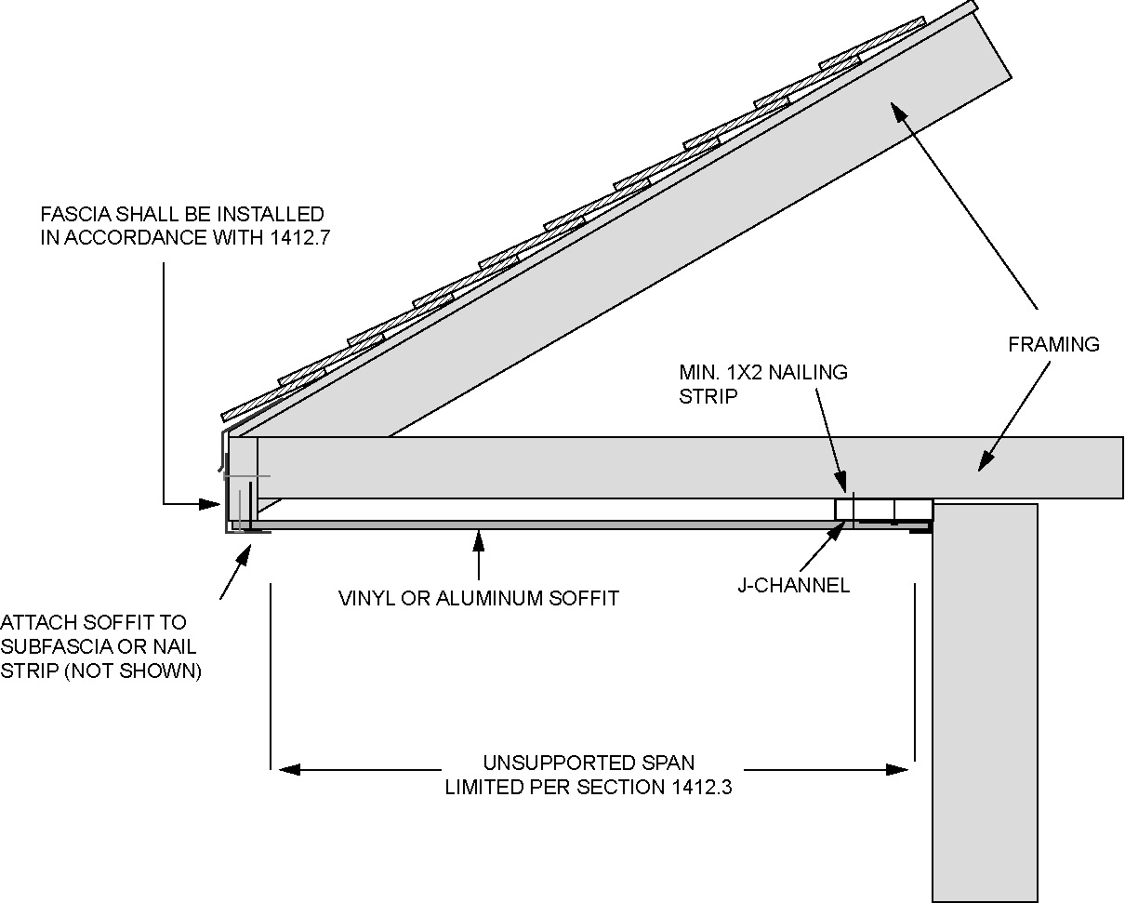
For SI: 1 inch = 25.4 mm.
FIGURE 1412.3(2)—DOUBLE-SPAN VINYL OR ALUMINUM SOFFIT PANEL SUPPORT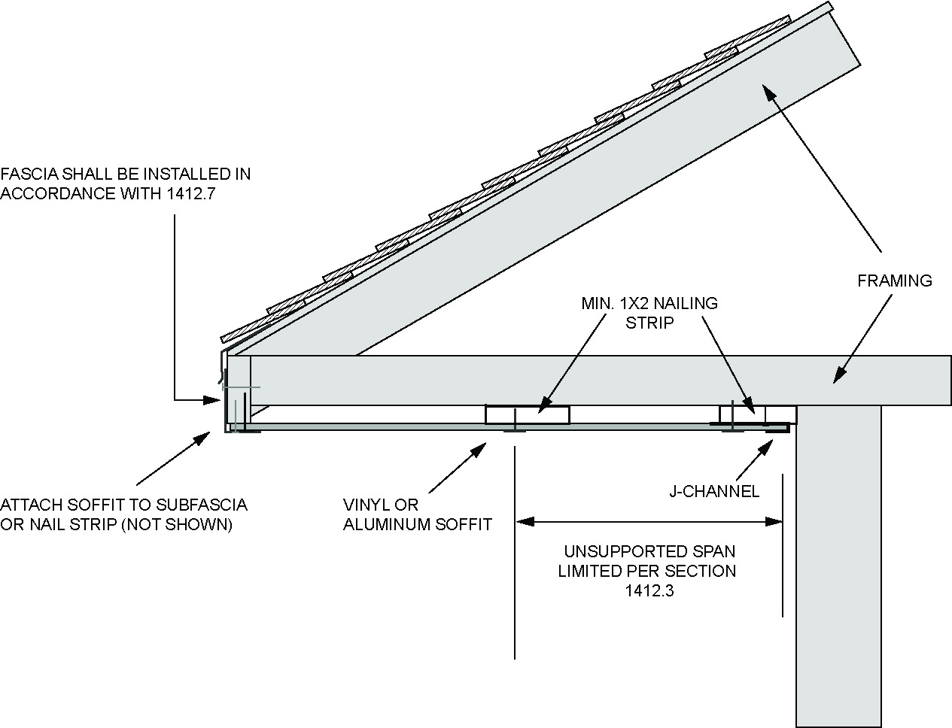
For SI: 1 inch = 25.4 mm.
1412.4 Fiber-Cement Soffit Panels
Fiber-cement soffit panels shall comply with Section 1412.2, shall be not less than 1/4 inch (6.4 mm) in thickness and shall comply with the requirements of ASTM C1186, Type A, minimum Grade II, or ISO 8336, Category A, minimum Class 2. Panel joints shall occur over framing or over wood structural panel sheathing. Soffit panels shall be installed with spans and fasteners in accordance with the manufacturer's installation instructions.
1412.5 Hardboard Soffit Panels
Hardboard soffit panels shall comply with Section 1412.2 and shall be not less than 7/16 inch (11.11 mm) in thickness and fastened to framing or nailing strips to meet the required design wind pressures. Where the design wind pressure is 30 pounds per square foot (1.44 kN/m²) or less, hardboard soffit panels are permitted to be attached to wood framing with 21/2-inch by 0.113-inch (64 mm by 2.9 mm) siding nails spaced not more than 6 inches (152 mm) on center at panel edges and 12 inches (305 mm) on center at intermediate supports. Soffit panels shall be installed with spans and fasteners in accordance with the manufacturer's installation instructions.
1412.6 Wood Structural Panel Soffit
Wood structural panel soffits shall comply with Section 1412.2 and shall have minimum panel performance category of ³/₈. Wood structural panel soffits are permitted to be attached to wood framing in accordance with Table 1412.6.
TABLE 1412.6—PRESCRIPTIVE ALTERNATE FOR WOOD STRUCTURAL PANEL SOFFIT^{b, c, d, e}
MAXIMUM  DESIGN  PRESSURE  (± psf) | MINIMUM PANEL  SPAN RATING | MINIMUM PANEL  PERFORMANCE  CATEGORY | NAIL TYPE AND SIZE | FASTENERª SPACING ALONG EDGES AND INTERMEDIATE SUPPORTS
 |  |  |  | Galvanized steel | Stainless steel
30 | 24/0 | 3/8 | 6d box  (2" × 0.099" × 0.266" head diameter) | 6f | 4
40 | 24/0 | 3/8 | 6d box  (2" × 0.099" × 0.266" head diameter) | 6 | 4
50 | 24/0 | 3/8 | 6d box  (2" × 0.099" × 0.266" head diameter) | 4 | 4
50 | 24/0 | 3/8 | 8d common  (2 ¹/₂" × 0.131" × 0.281" head diameter) | 6 | 6
60 | 24/0 | 3/8 | 6d box  (2" × 0.099" × 0.266" head diameter) | 4 | 3
60 | 24/0 | 3/8 | 8d common  (2 ¹/₂" × 0.131" × 0.281" head diameter) | 6 | 4
70 | 24/16 | 7/16 | 8d common  (2 ¹/₂" × 0.131" × 0.281" head diameter) | 4 | 4
70 | 24/16 | 7/16 | 10d box  (3" × 0.128" × 0.312" head diameter) | 6 | 4
80 | 24/16 | 7/16 | 8d common  (2 ¹/₂" × 0.131" × 0.281" head diameter) | 4 | 4
80 | 24/16 | 7/16 | 10d box  (3" × 0.128" × 0.312" head diameter) | 6 | 4
90 | 32/16 | 15/32 | 8d common  (2 ¹/₂" × 0.131" × 0.281" head diameter) | 4 | 3
90 | 32/16 | 15/32 | 10d box  (3" × 0.128" × 0.312" head diameter) | 6 | 4
For SI: 1 inch = 25.4 mm.
- Fasteners shall comply with Section 1412.6.
- Maximum spacing of soffit framing members shall not exceed 24 inches (610 mm).
- Wood structural panels shall be of an exterior exposure grade.
- Wood structural panels shall be installed with strength axis perpendicular to supports with a minimum of two continuous spans.
- Wood structural panels shall be attached to soffit framing members with specific gravity of at least 0.42. Framing members shall be minimum 2" x 3" nominal with the larger dimension in the cross section aligning with the length of fasteners to provide sufficient embedment depths.
- Spacing at intermediate supports is permitted to be 12 inches on center.
1412.7 Aluminum Fascia
Aluminum fascia shall comply with Section 1412.2 and shall be not less than 0.019 inches (0.48 mm) in thickness and installed in accordance with manufacturer's instructions. Aluminum fascia shall be attached to wood frame construction in accordance with Section 1412.7.1 or 1412.7.2.
1412.7.1 Fascia Installation Where the Design Wind Pressure Is 30 psf (1.44 kN/m²) or Less
Where the design wind pressure is 30 pounds per square foot (1.44 kN/m²) or less, aluminum fascia shall be a attached with one finish nail (¹¹/₄ inches × 0.057 inch × 0.177 inch head diameter) (32 mm × 1.4 mm × 4.5 mm) in the return leg spaced not greater than 24 inches (610 mm) on center, and the fascia shall be inserted under the drip edge with not less than 1 inch (25 mm) of fascia material covered by the drip edge. Where the fascia cannot be inserted under the drip edge, the top edge of the fascia shall be secured using one finish nail (¹¹/₄ inches × 0.057 inch × 0.177 inch head diameter) (32 mm × 1.4 mm × 4.5 mm) located not more than 1 inch (25 mm) below the drip edge and spaced not greater than 24 inches (610 mm) on center.
1412.7.2 Fascia Installation Where the Design Wind Pressure Exceeds 30 psf (1.44 kN/m²)
Where the design wind pressure is greater than 30 pounds per square foot (1.44 kN/m²), aluminum fascia shall be attached with one finish nail (¹¹/₄ inches × 0.057 inch × 0.177 inch head diameter) (32 mm × 1.4 mm × 4.5 mm) in the return leg spaced a maximum of 16 inches (406 mm) on center and one finish nail located not greater than 1 inch (25 mm) below the drip edge spaced a maximum of 16 inches (406 mm) on center. As an alternative, the top edge of the fascia is permitted to be secured using utility trim installed beneath the drip edge with snap locks punched into the fascia spaced not greater than 6 inches (152 mm) on center.
Section 1413 [DSA-SS & DSA-SS/CC, OSHPD 1, 1R, 2, 4 & 5] Additional Requirements for Anchored and Adhered Veneer
1413.1 General
In no case shall veneer be considered as part of the backing in computing strength or deflection, nor shall it be considered a part of the required thickness of the backing.
Veneer shall be anchored in a manner which will not allow relative movement between the veneer and the wall.
Anchored or adhered veneer shall not be used on overhead horizontal surfaces.
1413.2 Adhered Veneer
Units of tile, masonry, stone or terra cotta which exceed ⁵/₈ inch (15.9 mm) in thickness shall be applied as for anchored veneer where used over exit ways or more than 20 feet (6.1 m) in height above adjacent ground elevation.
1413.2.1 Bond Strength and Tests
Irrespective of the mortar type, veneer type or design methodology used, adhered masonry veneer shall develop a bond shear strength to the backing of at least 50 psi (345 kPa) based on gross unit bonded area. The bond between adhered veneer units and backing shall be shear tested, in accordance with ASTM C1823, on a field-constructed mock-up using the specified unit, mortar and substrate.
Not less than two shear tests shall be performed for the adhered veneer between the units and the supporting element. At least one shear test shall be performed at each building for each 5,000 square feet (465 m²) of wall area or fraction thereof.
1413.2.2 TMS 402, Section 13.3.2.2
Replace TMS 402, Section 13.3.2.2 (c) with the following:
- (c) The weight of adhered masonry veneer units shall not exceed 15 psf (73 kg/m²).

